**Workforce Administration Solution (Admin)**

By

# [Subhrajit Chatterjee](mailto:subhrajitchatterjee251@gmail.com)

### subhrajit.chatterjee.csbs25@heritageit.edu.in

# **Project Abstract**

The Workforce Administration Solution is a comprehensive software application designed to optimize and automate the management of employee activities and asset assignments within an organization. This platform serves as a centralized system for efficiently handling employee data, tracking the number of projects each employee is engaged in, monitoring performance metrics, and maintaining detailed records of assets assigned to employees. By streamlining these processes, the Workforce Administration Solution enhances operational efficiency, promotes better resource allocation, and provides valuable insights into workforce productivity and asset utilization. This solution aims to support organizational growth and operational excellence through improved workforce management and asset tracking capabilities.

# **INDEX**

**Topics PageNo**

Project Abstract ---------------------------------------------------------------------------------------- 02

Introduction —------------------------------------------------------------------------------------------ 04

Salesforce ---------------------------------------------------------------------------------------------- 04

Objects -------------------------------------------------------------------------------------------------- 06

Tabs ------------------------------------------------------------------------------------------------------ 09

The Lightning App ------------------------------------------------------------------------------------ 11

Fields &

Relationship --------------------------------------------------------------------------------------------- 12

Setting OWD -------------------------------------------------------------------------------------------- 22

User Adoption ------------------------------------------------------------------------------------------- 23

Import Data ---------------------------------------------------------------------------------------------- 26

Profiles --------------------------------------------------------------------------------------------------- 27

Role ------------------------------------------------------------------------------------------------------ 31

Users --------------------------------------------------------------------------------------------------- 32

Page layouts ------------------------------------------------------------------------------------------ 35

Chatter Groups --------------------------------------------------------------------------------------- 37

Record Types ---------------------------------------------------------------------------------------- 38

Permission Sets ------------------------------------------------------------------------------------- 40

Reports ------------------------------------------------------------------------------------------------ 41

Dashboard -------------------------------------------------------------------------------------------- 43

## **INTRODUCTION**

The Workforce Administration Solution is a state-of-the-art software application designed to streamline and automate the management of employee activities and asset assignments within organizations. This comprehensive platform serves as a centralized hub for efficiently handling employee data, tracking project engagements, monitoring performance metrics, and maintaining detailed records of assigned assets. By integrating these processes, the Workforce Administration Solution enhances operational efficiency, promotes optimal resource allocation, and provides valuable insights into workforce productivity and asset utilization. This solution aims to support organizational growth and operational excellence through improved workforce management and asset tracking capabilities.

# ***Salesforce***

## TASK 1: **Creating Developer Account**

1. Go to <https://developer.salesforce.com/signup>
2. Fill up form with personal information

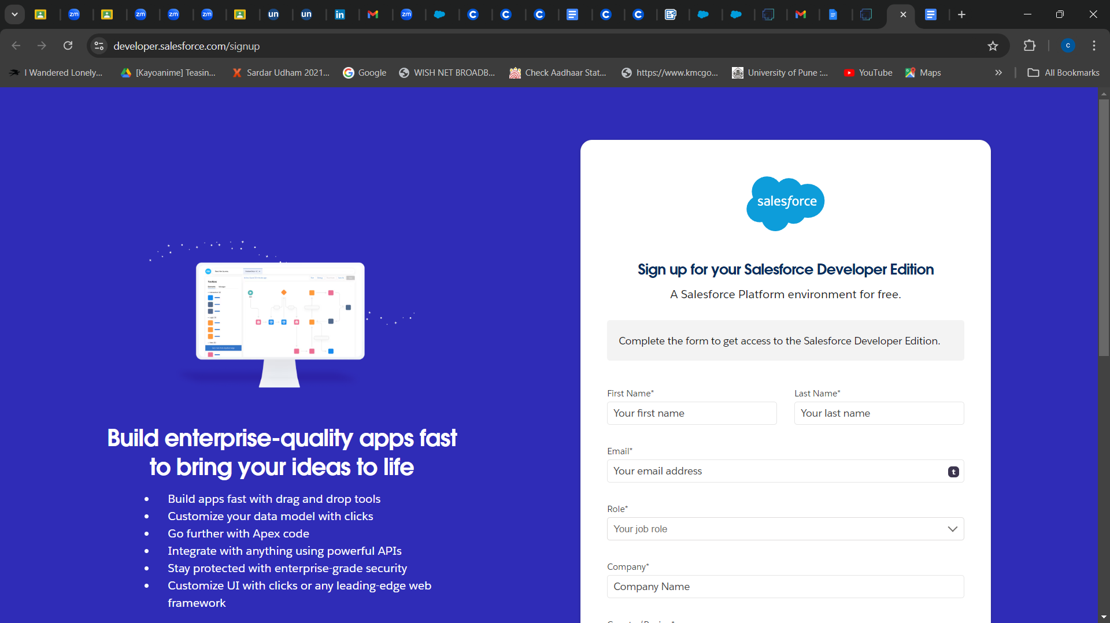

## TASK 2: **Account Activation**

1. Go to the inbox of the email that you used while signing up. Click on the verify account to activate your account.
2. Give a password and answer a security question and click on change password.
3. Then you will redirect to your salesforce setup page.

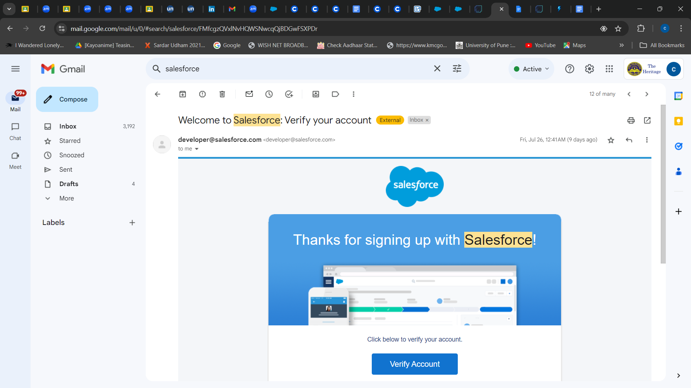

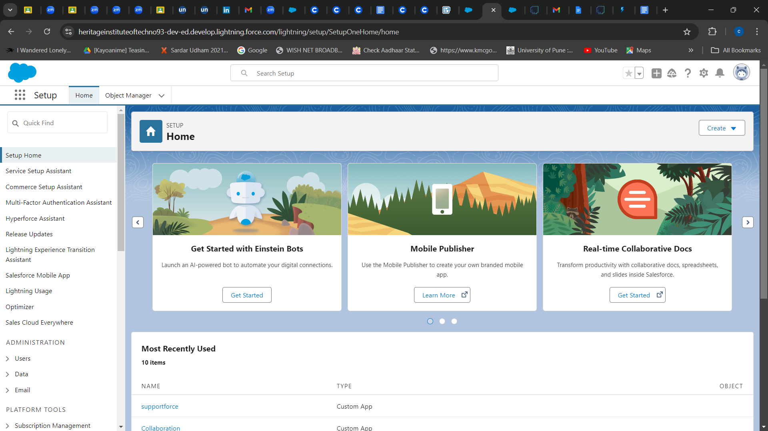

# ***Objects***

## TASK 3: **Create Employee Object**

1. From the setup page --> Click on Object Manager --> Click on Create --> Click on Custom Object.
2. Enter the label name: Employee and Plural label name: Employees
3. Enter Record Name Label and Format
4. Click on Allow reports,
5. Allow search --> Save.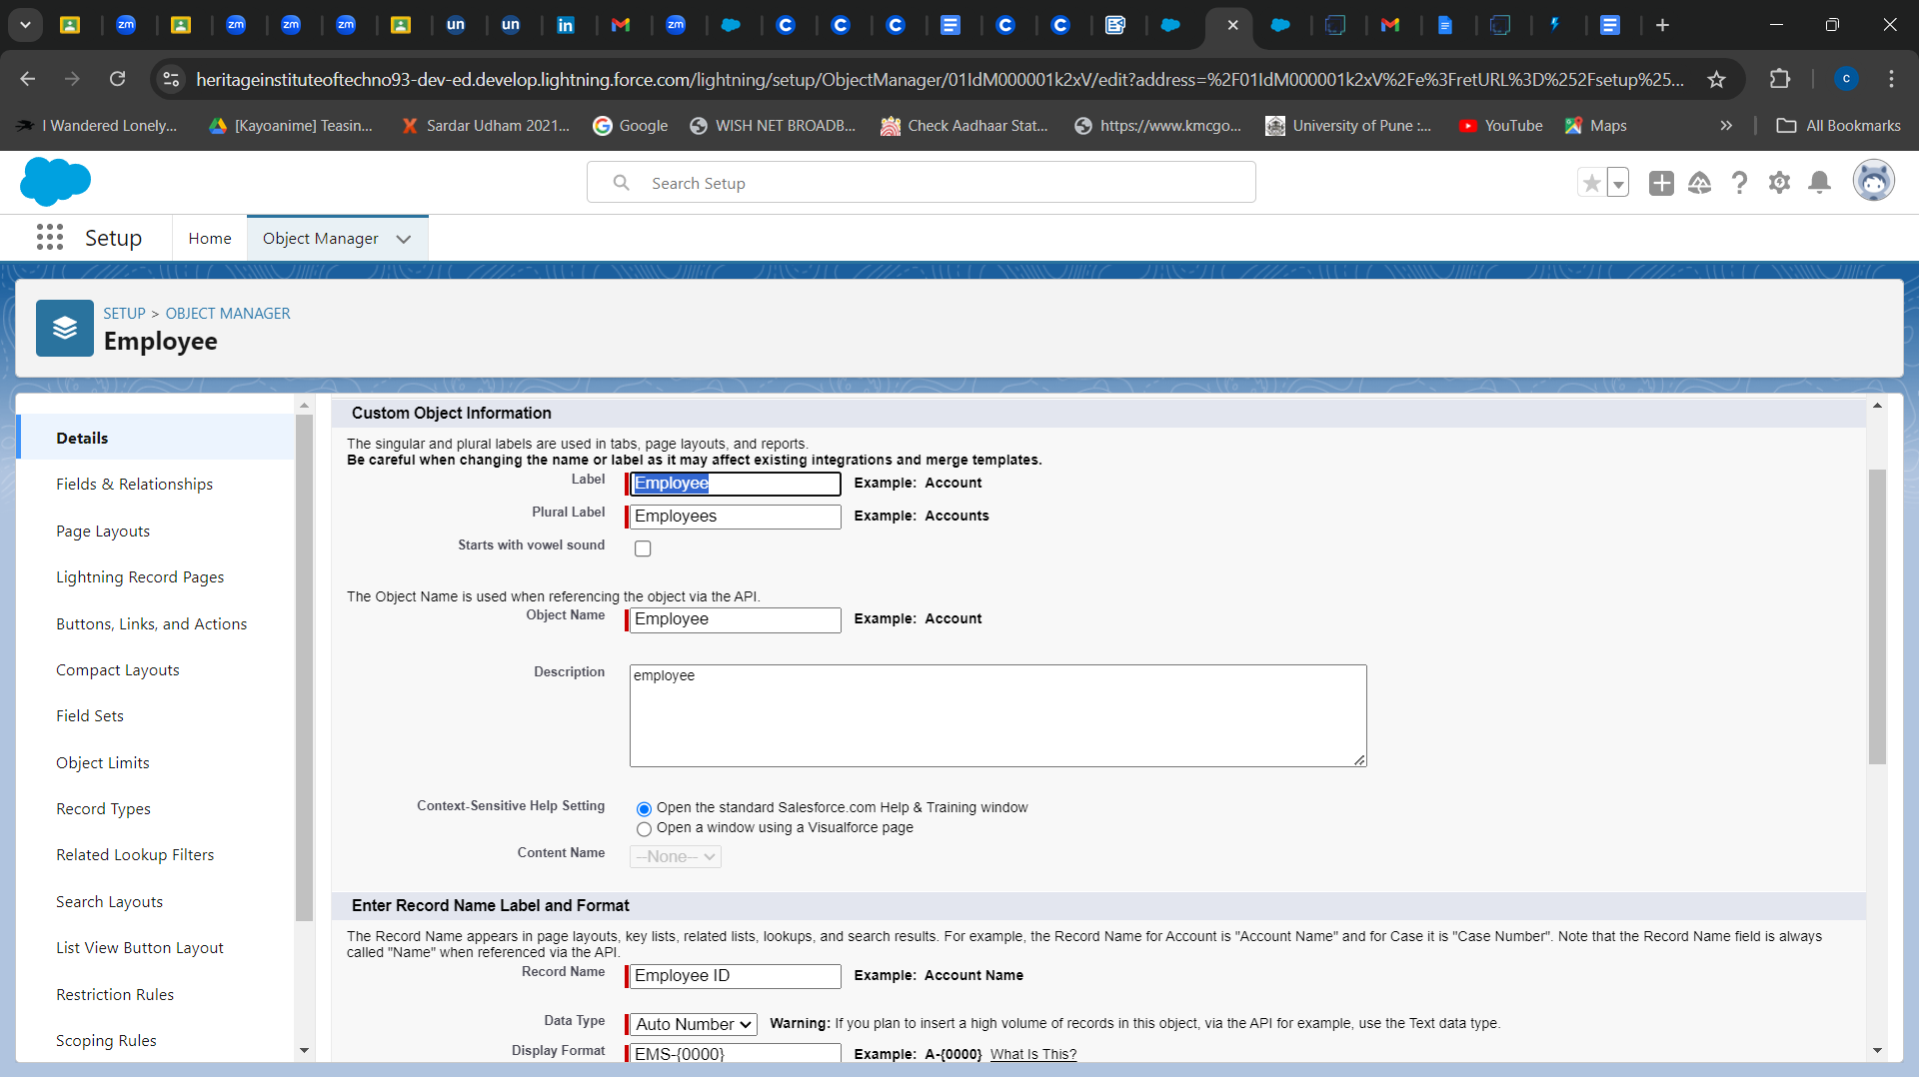

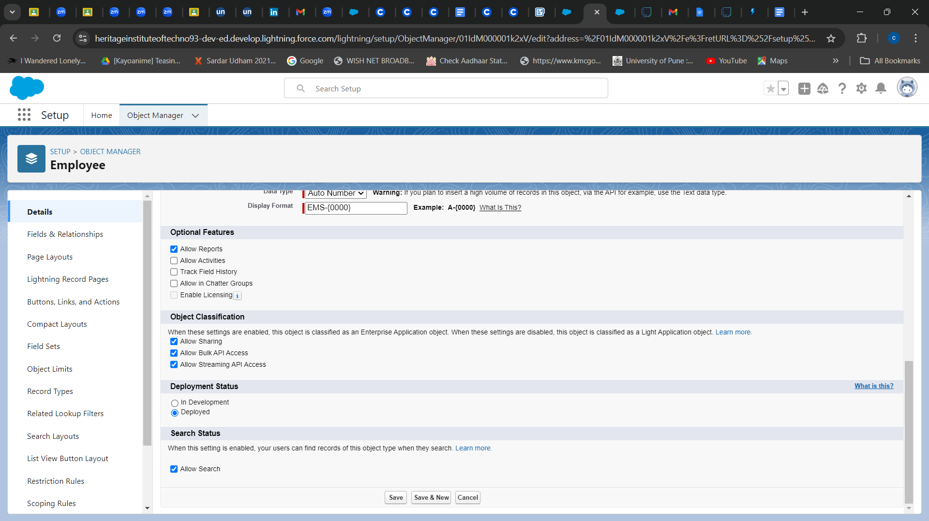

## TASK 4: **Create Project Object**

1. From the setup page --> Click on Object Manager --> Click on Create → Click on Custom Object.

1) Enter the label name--> Project

2) Plural label name--> Projects

3) Enter Record Name Label and Format

1 Record Name : Project ID

2 Data Type : Auto Number

3 Display Format : Proj-{0000}

4 Starting Number : 1

2. Click on Allow reports,

3. Allow search --> Save

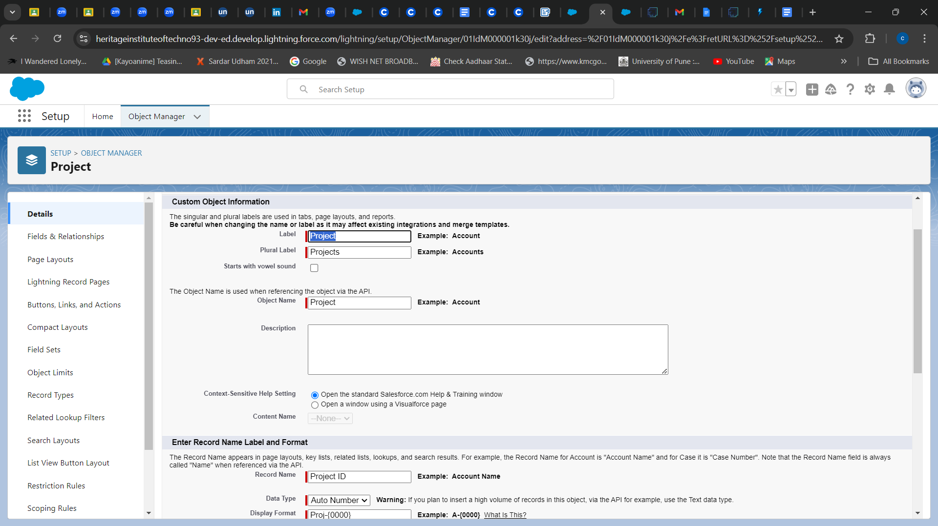

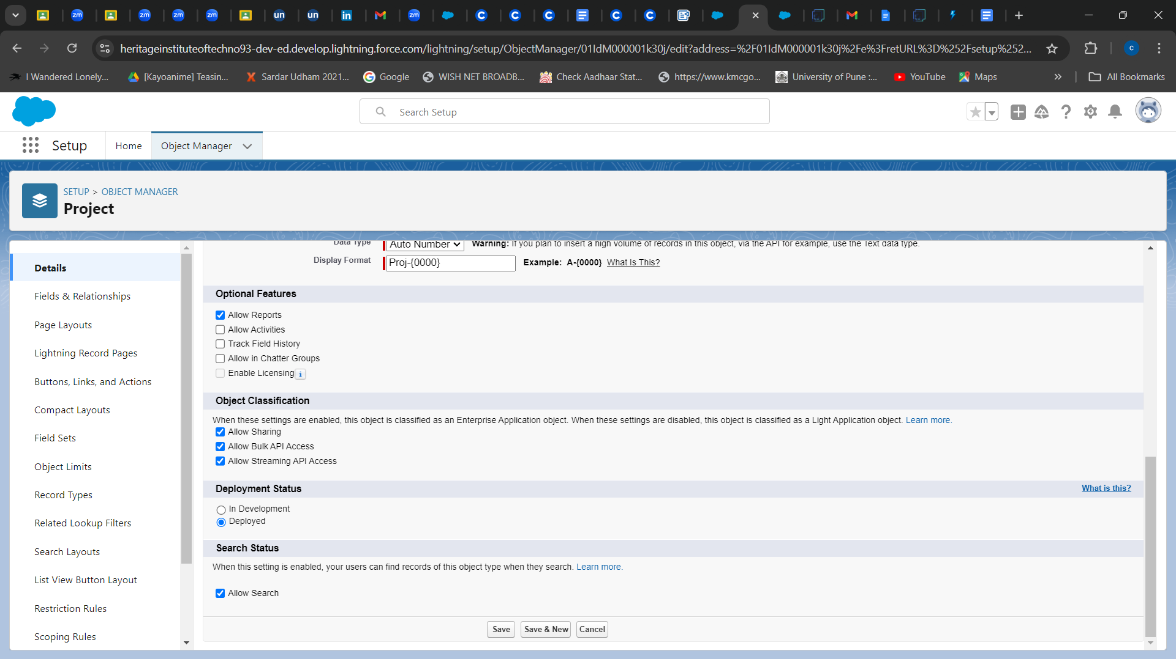

## TASK 5: **Create ProjectTask, Asset, Asset Service Object**

1. From the setup page --> Click on Object Manager --> Click on Create --> Click on Custom Object.
2. Enter the label name and the Plural label name.
3. Enter Record Name Label and Format
4. Allow search --> Save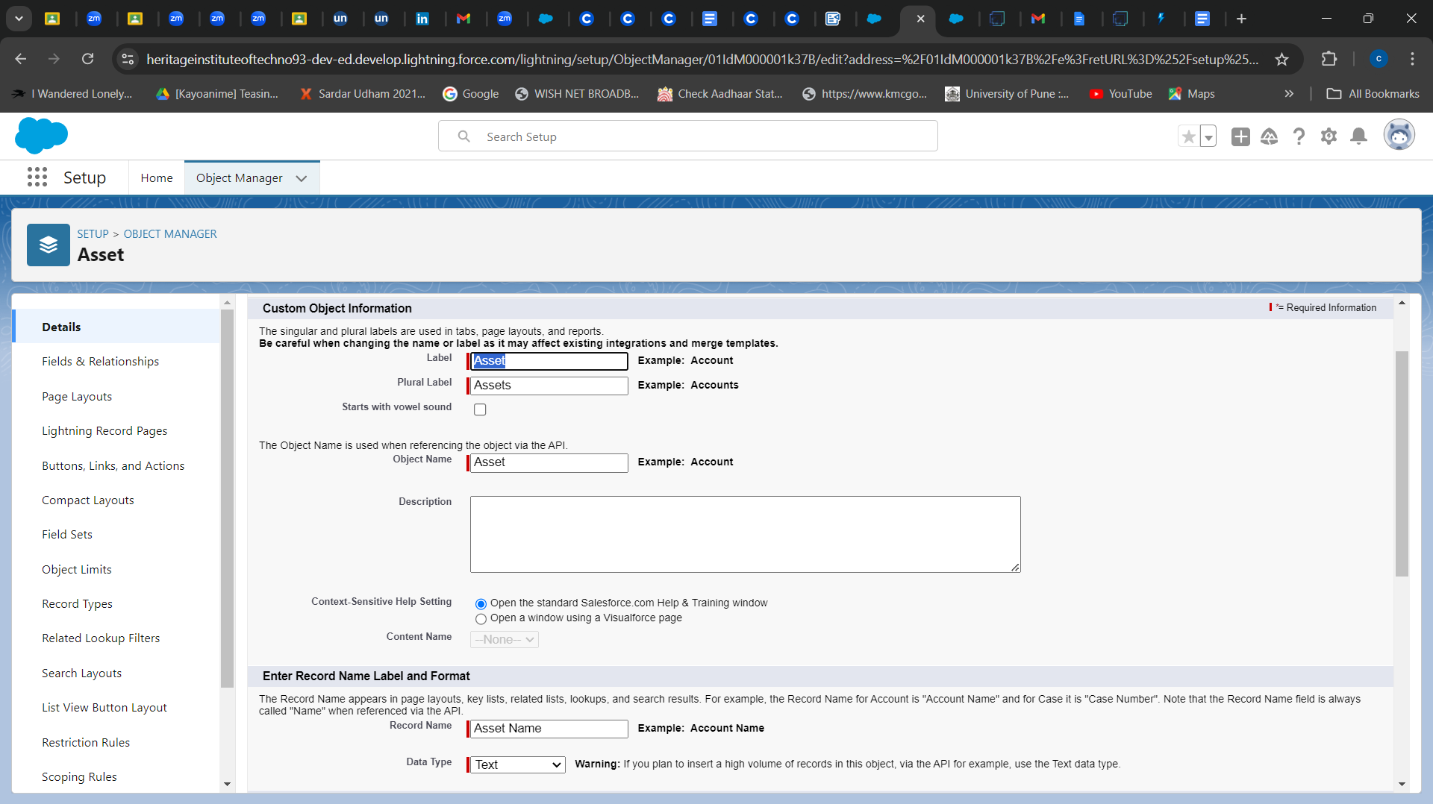

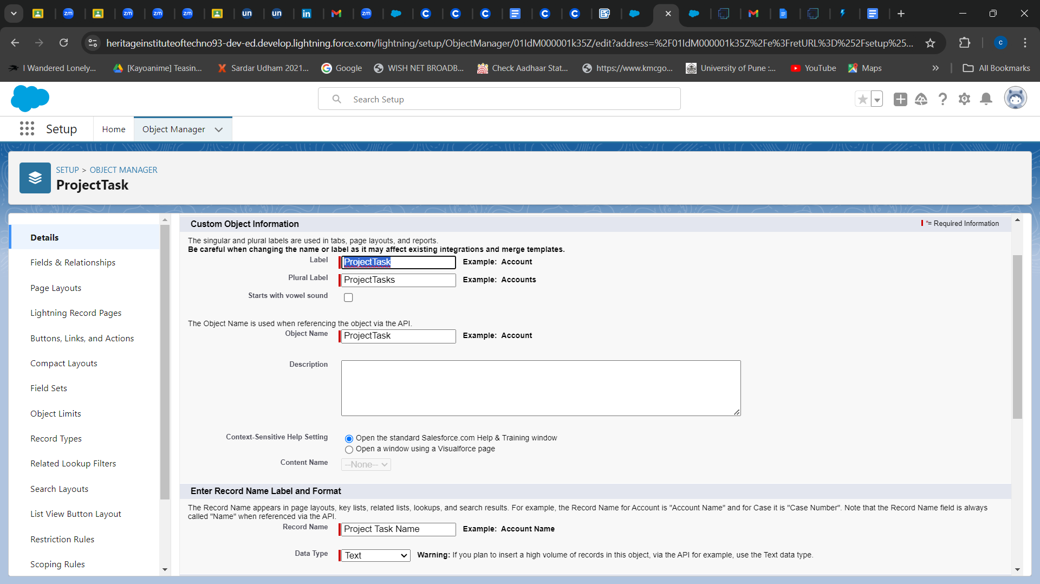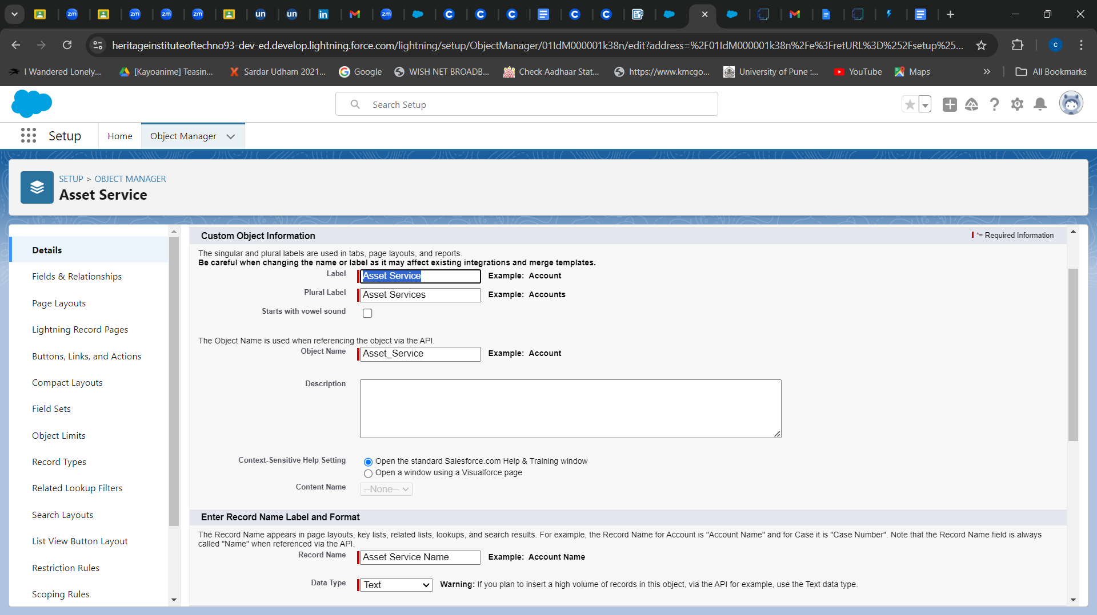

# ***Tabs***

## TASK 6: **Creating a Custom Tab (Employee)**

1. Go to setup page --> type Tabs in Quick Find bar --> click on tabs --> New (under custom object tab )
2. Select Object(Employee) --> Select any tab style --> Next (Add to profiles page) keep it as default --> Next (Add to Custom App) keep it as default --> Save.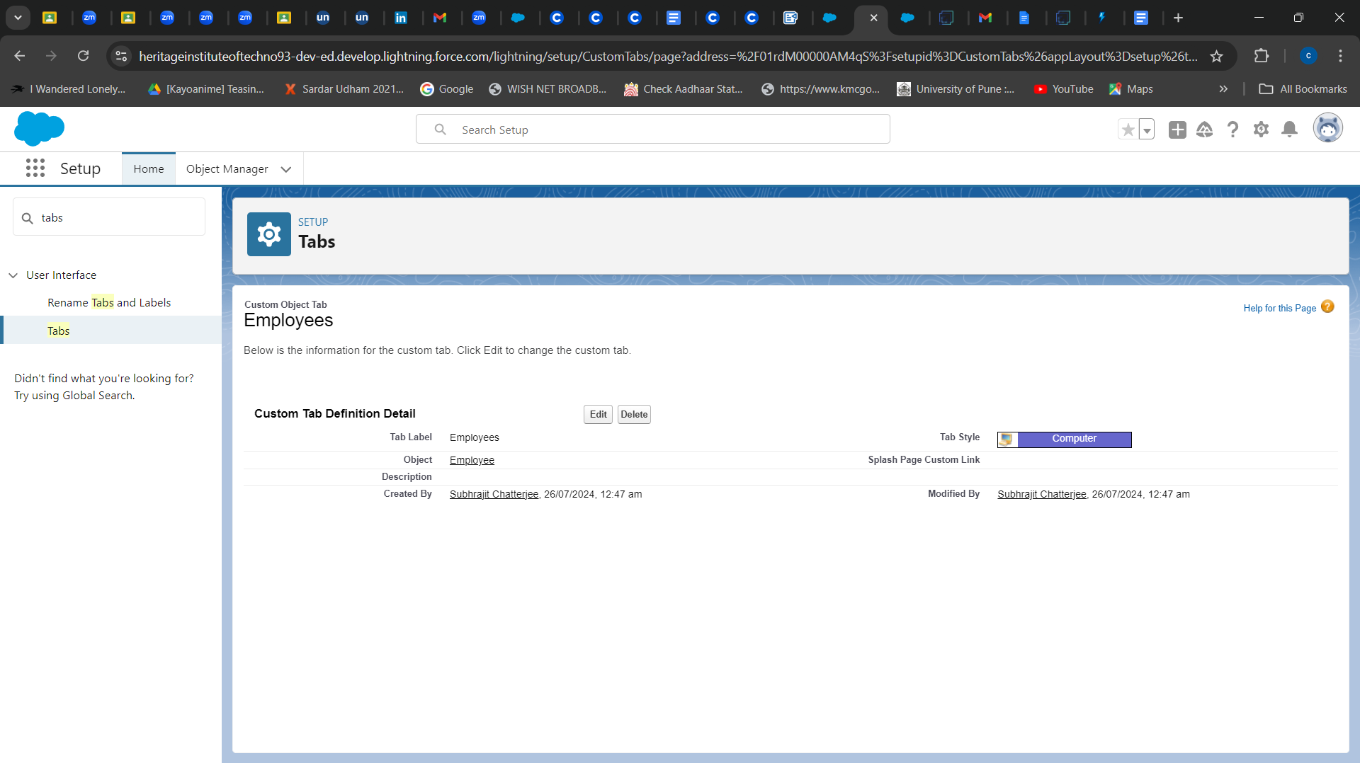

## 

## TASK 7: **Creating a Custom Tab (Project)**

1. Go to setup page --> type Tabs in Quick Find bar --> click on tabs --> New (under custom object tab )
2. Select Object(Project) --> Select any tab style --> Next (Add to profiles page) keep it as default --> Next (Add to Custom App) keep it as default --> Save.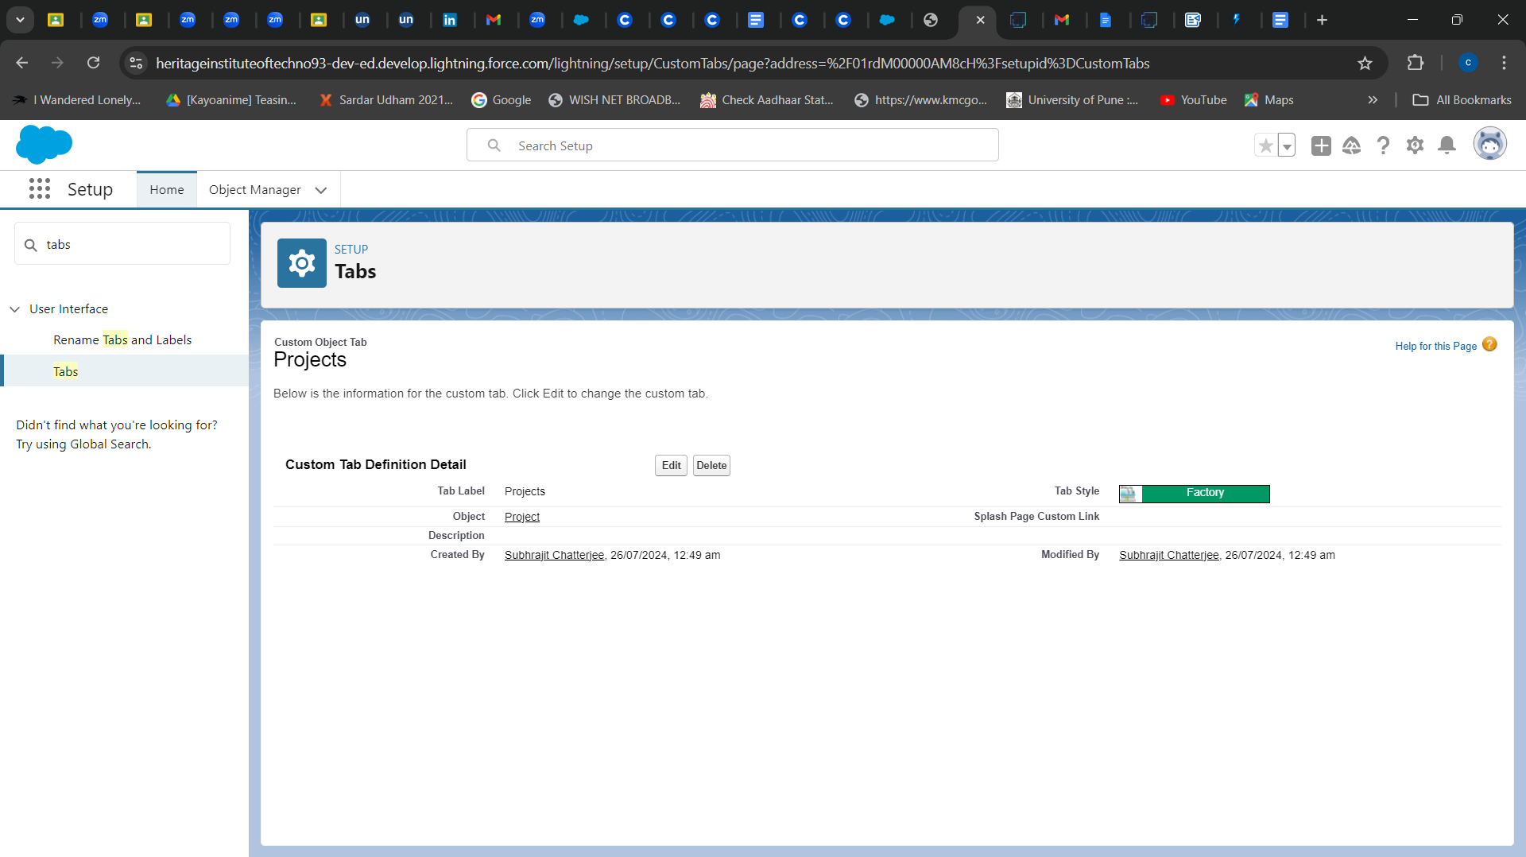

## TASK 8: **Creating tabs for remaining objects**

1. Go to setup page --> type Tabs in Quick Find bar --> click on tabs --> New (under custom object tab )
2. Select Object( Project Task) --> Select any tab style --> Next (Add to profiles page) keep it as default --> Next (Add to Custom App) keep it as default --> Save.
3. Repeat step 1 and 2 for Asset, Asset Service objects.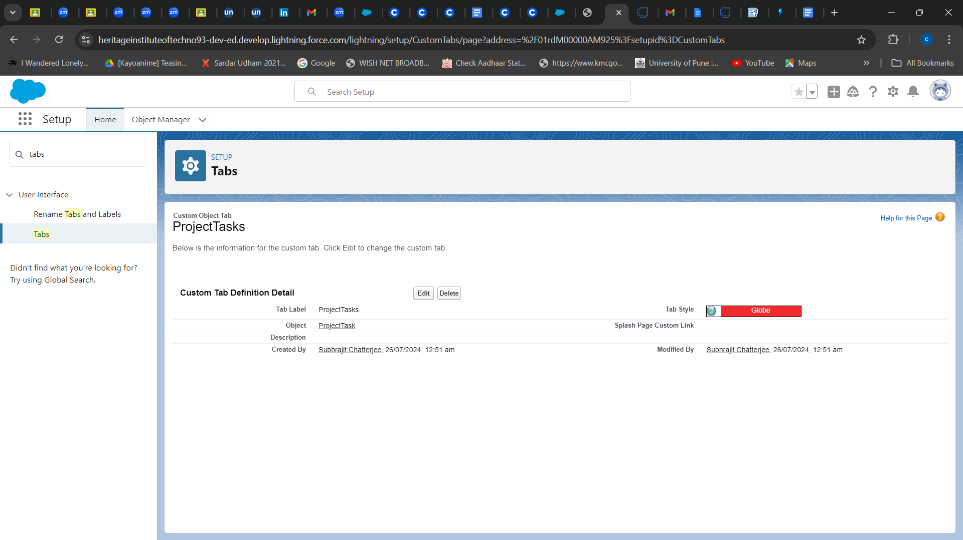

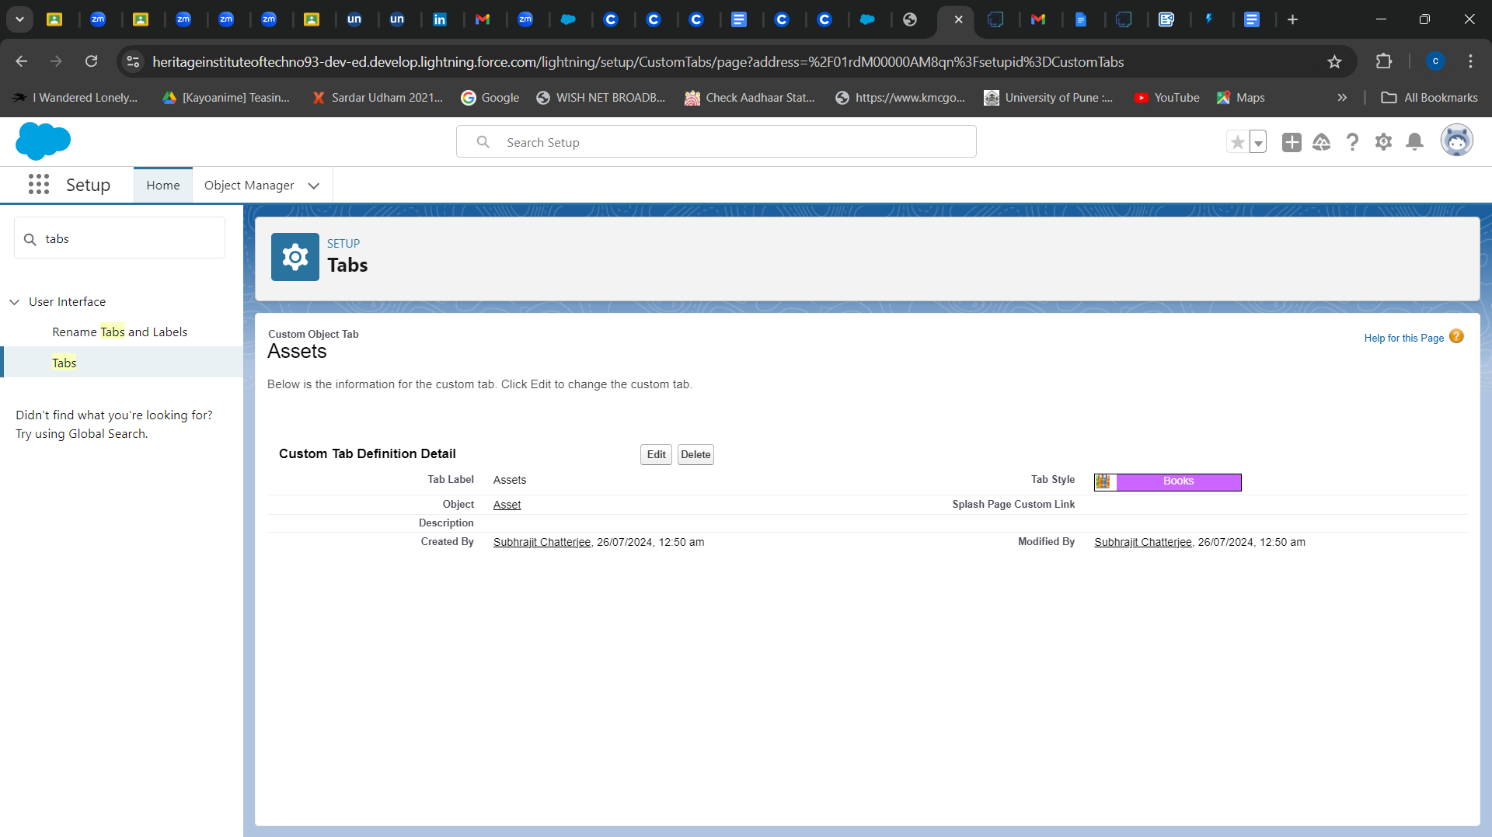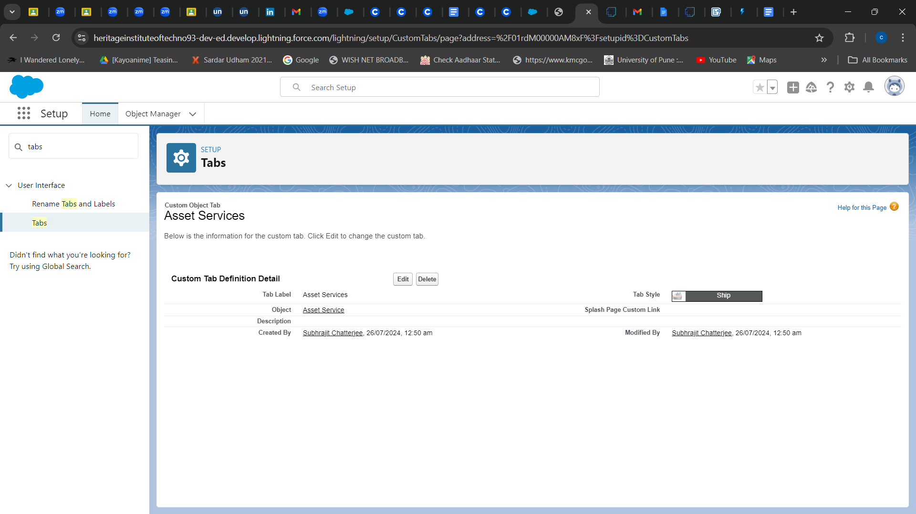

# ***The Lightning App***

## TASK 9: **Create a Lightning App**

1. Go to the setup page --> search “app manager” in quick find --> select “app manager” --> click on New lightning App.
2. Fill the app name in app details and branding
3. Then click Next --> (App option page) keep it as default --> Next --> (Utility Items) keep it as default --> Next.
4. To Add Navigation Items: Search the items in the search bar(Employees, Projects, ProjectTask, Assets, Asset Services, Reports, Dashboard) from the search bar and move it using the arrow button --> Next.
5. Search profiles (System administrator) in the search bar --> click on the arrow button --> save & finish.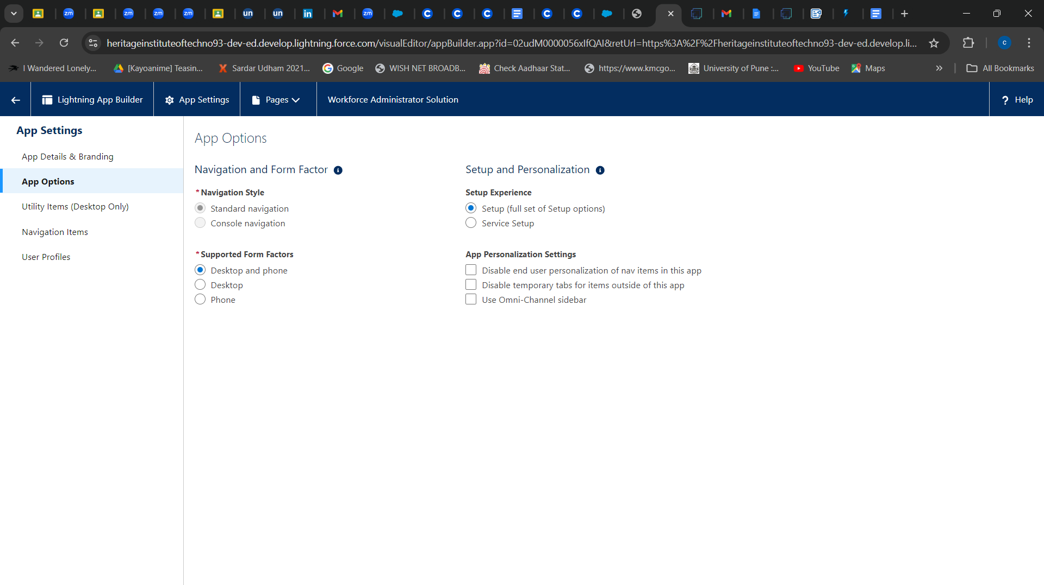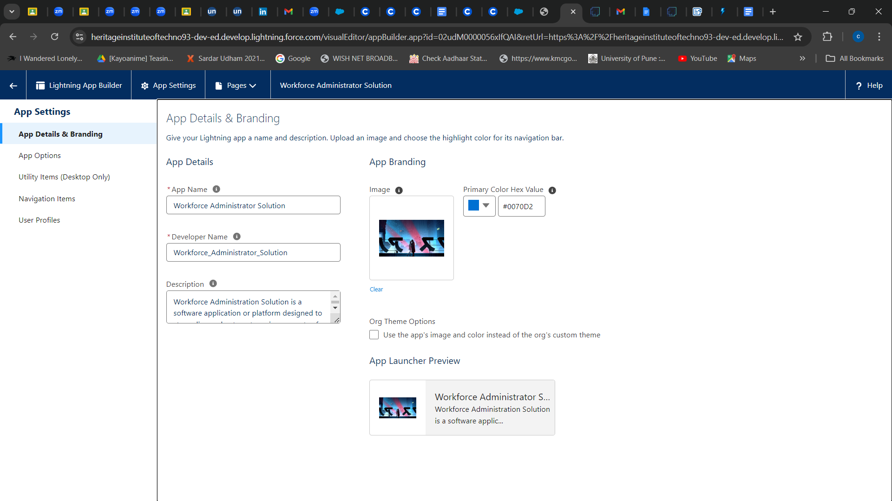

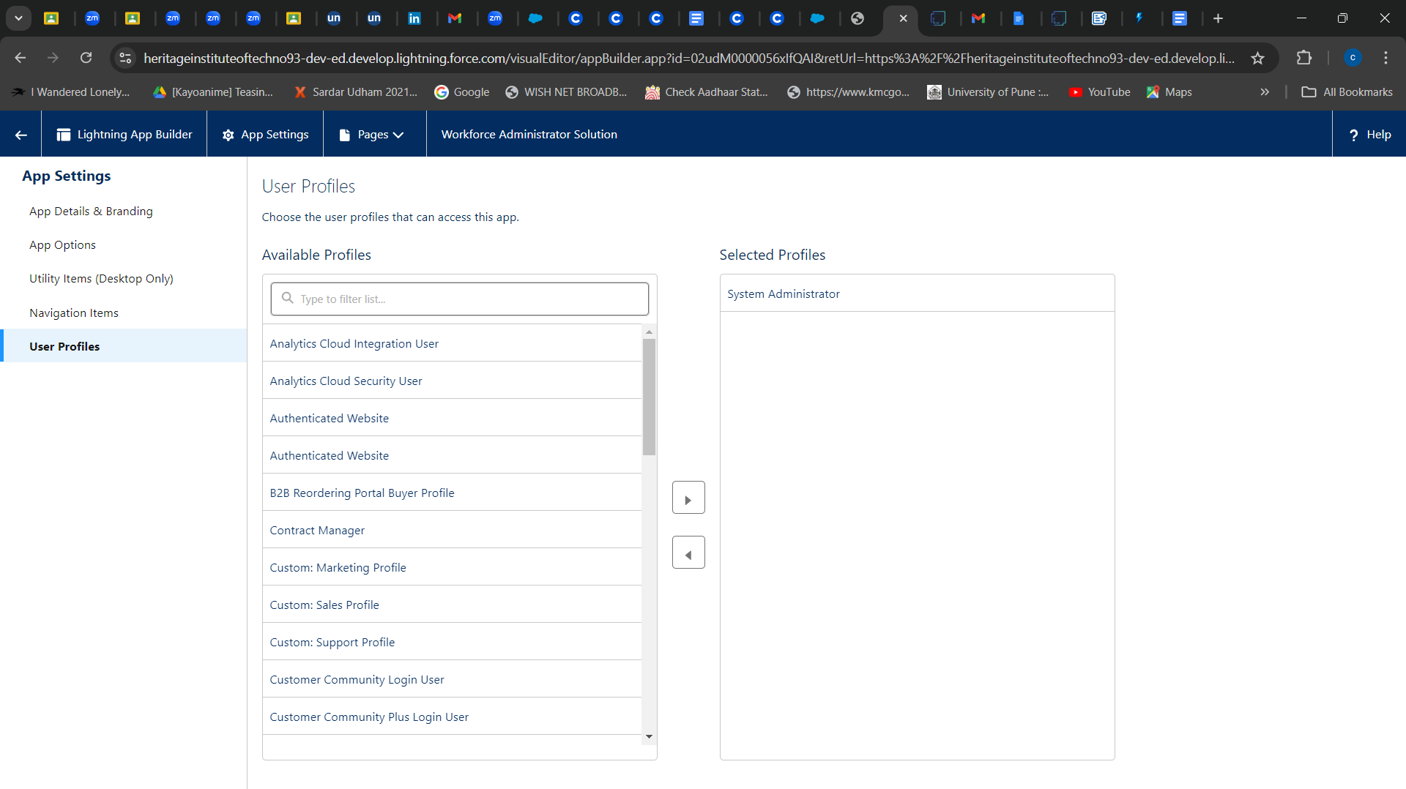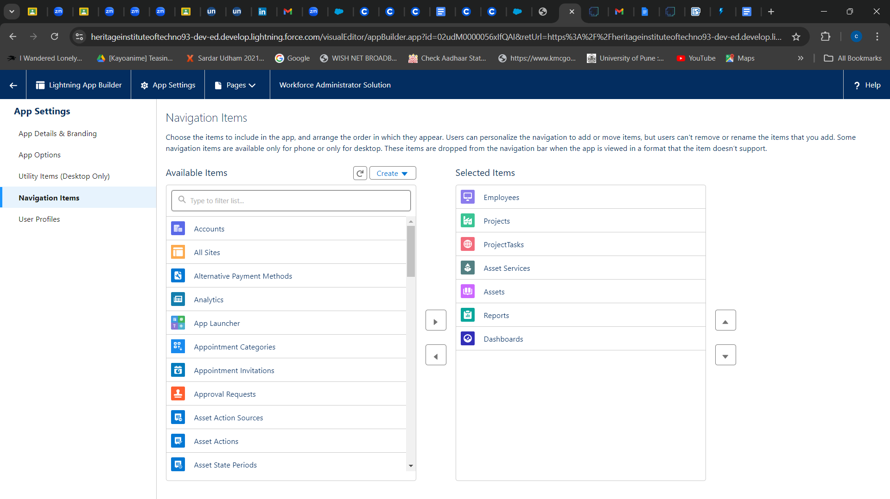

# 

# ***Fields & Relationships***

# TASK 10: **Creating Text Field in Employee Object**

1. Go to setup --> click on Object Manager --> type object name(Employee) in quick find bar --> click on the object.
2. Now click on “Fields & Relationships” --> New
3. Select Data type as “Text”.
4. Click on Next
5. Fill the above as following:

Field Label: Employee Name

Length : 18

Field Name : gets auto generated

Click on Next --> Next --> Save and new.

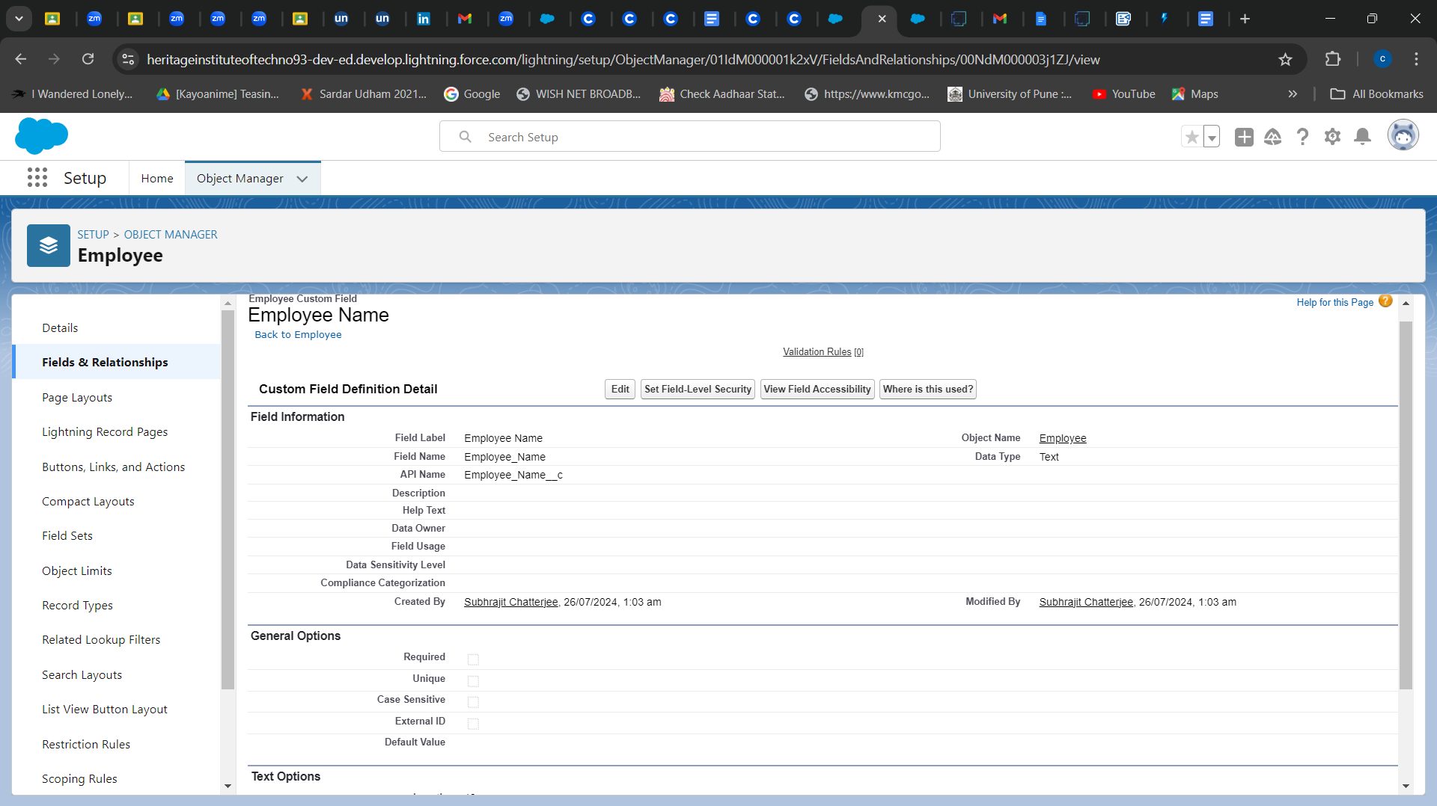

## TASK 11: **Creating Date of Birth Field in Employee Object**

1. Repeat step 1 and 2 mentioned in task 10
2. Select Data type as “Date” and click Next.
3. Click on Next.
4. Fill the above as following:

Field Label: Date of Birth.

Field Name : gets auto generated

Click on Next --> Next --> Save and new.

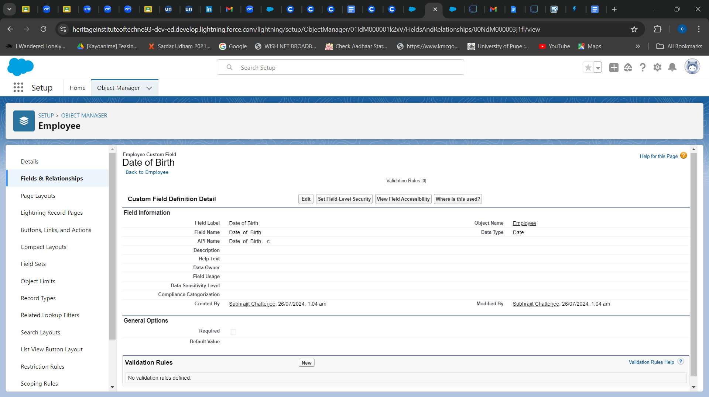

## TASK 12: **Creating Formula Field in Employee Object**

1. Repeat step 1 and 2 mentioned in task 10
2. Select Data type as “Formula” and click Next.
3. Give Field Label and Field Name as “Age” and select formula return type as “Number” and click next.
4. Write the formula - YEAR( TODAY() ) - YEAR( Date_of_Birth__c ) and click “Check Syntax” and Next --> Next --> Save & New.

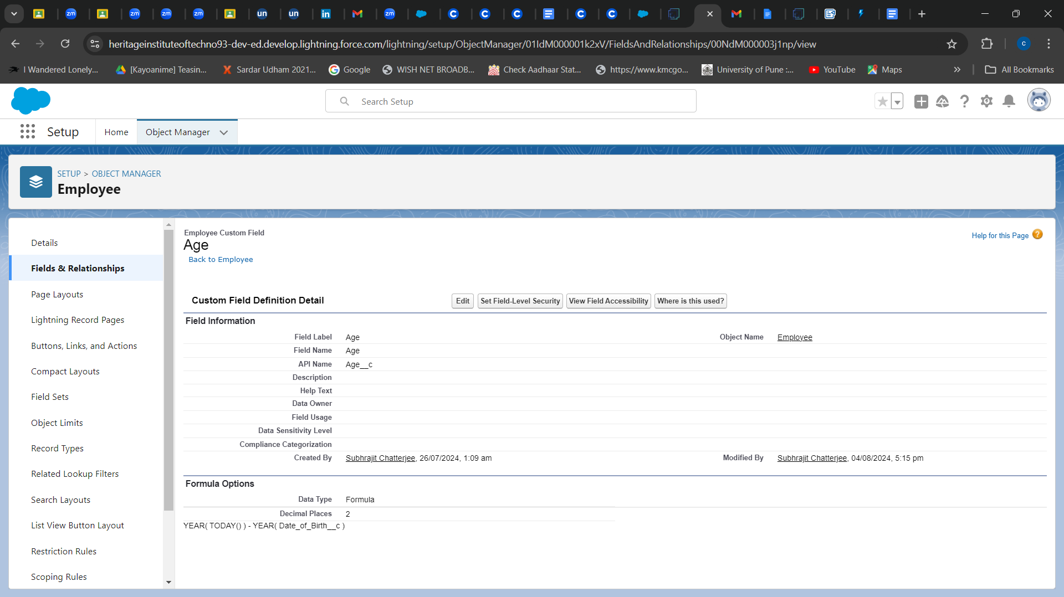

## TASK 13: **Creating Picklist Field in Employee Object**

1. Repeat step 1 and 2 mentioned in task 10
2. Select Data type as “Picklist” and click Next
3. Enter Field Label as “Gender”, under values select “Enter values, with each value separated by a new line" and enter “male” , “female”
4. Click Next --> Next --> Next --> Save & New.

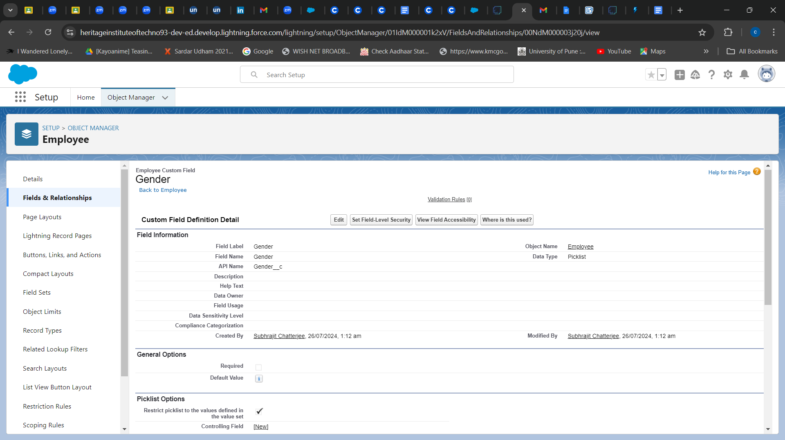

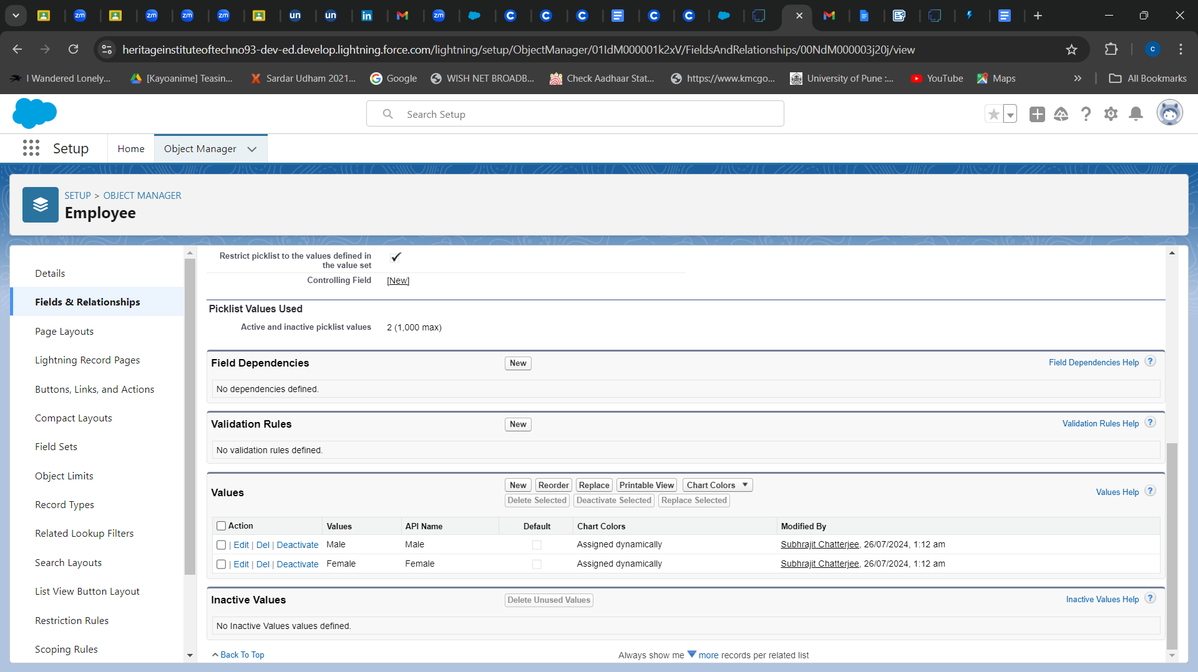

## TASK 14: **Creating Self-Relationship Field in Employee Object**

1. Repeat step 1 and 2 mentioned in task 10
2. Select Data type as “Lookup Relationship” and click Next.
3. Select Employee from the drop down related to the field and click Next.
4. Give Field Label as “Reports to” and click Next.
5. Next --> Next --> Save & New.

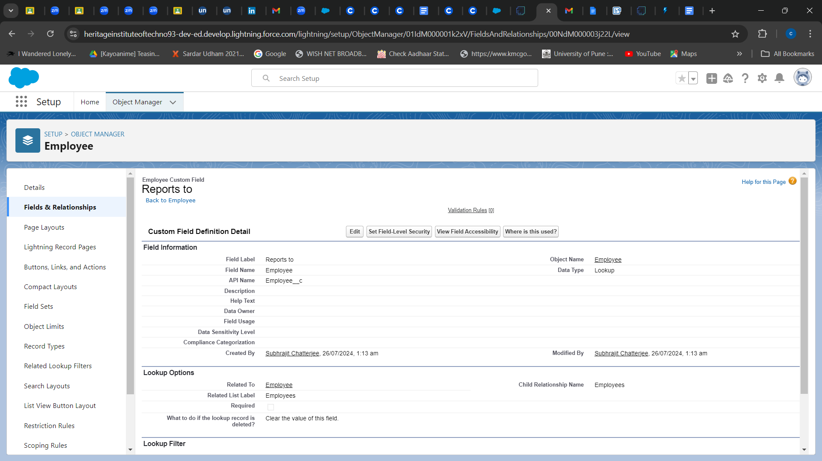

## TASK 15: **Creating Master-Detail Relationship between Employee & Asset Object**

1. Go to the setup page --> click on object manager --> type object name(ProjectTask) in the quick find bar --> click on the object.
2. Click on fields & relationship --> click on New.
3. Select “Master-Detail relationship” as data type and click Next.
4. For field label related to: select “Employee” object and click Next.
5. Give Field Label as “Employee Name” and click Next.
6. Next --> Next --> Save & New.

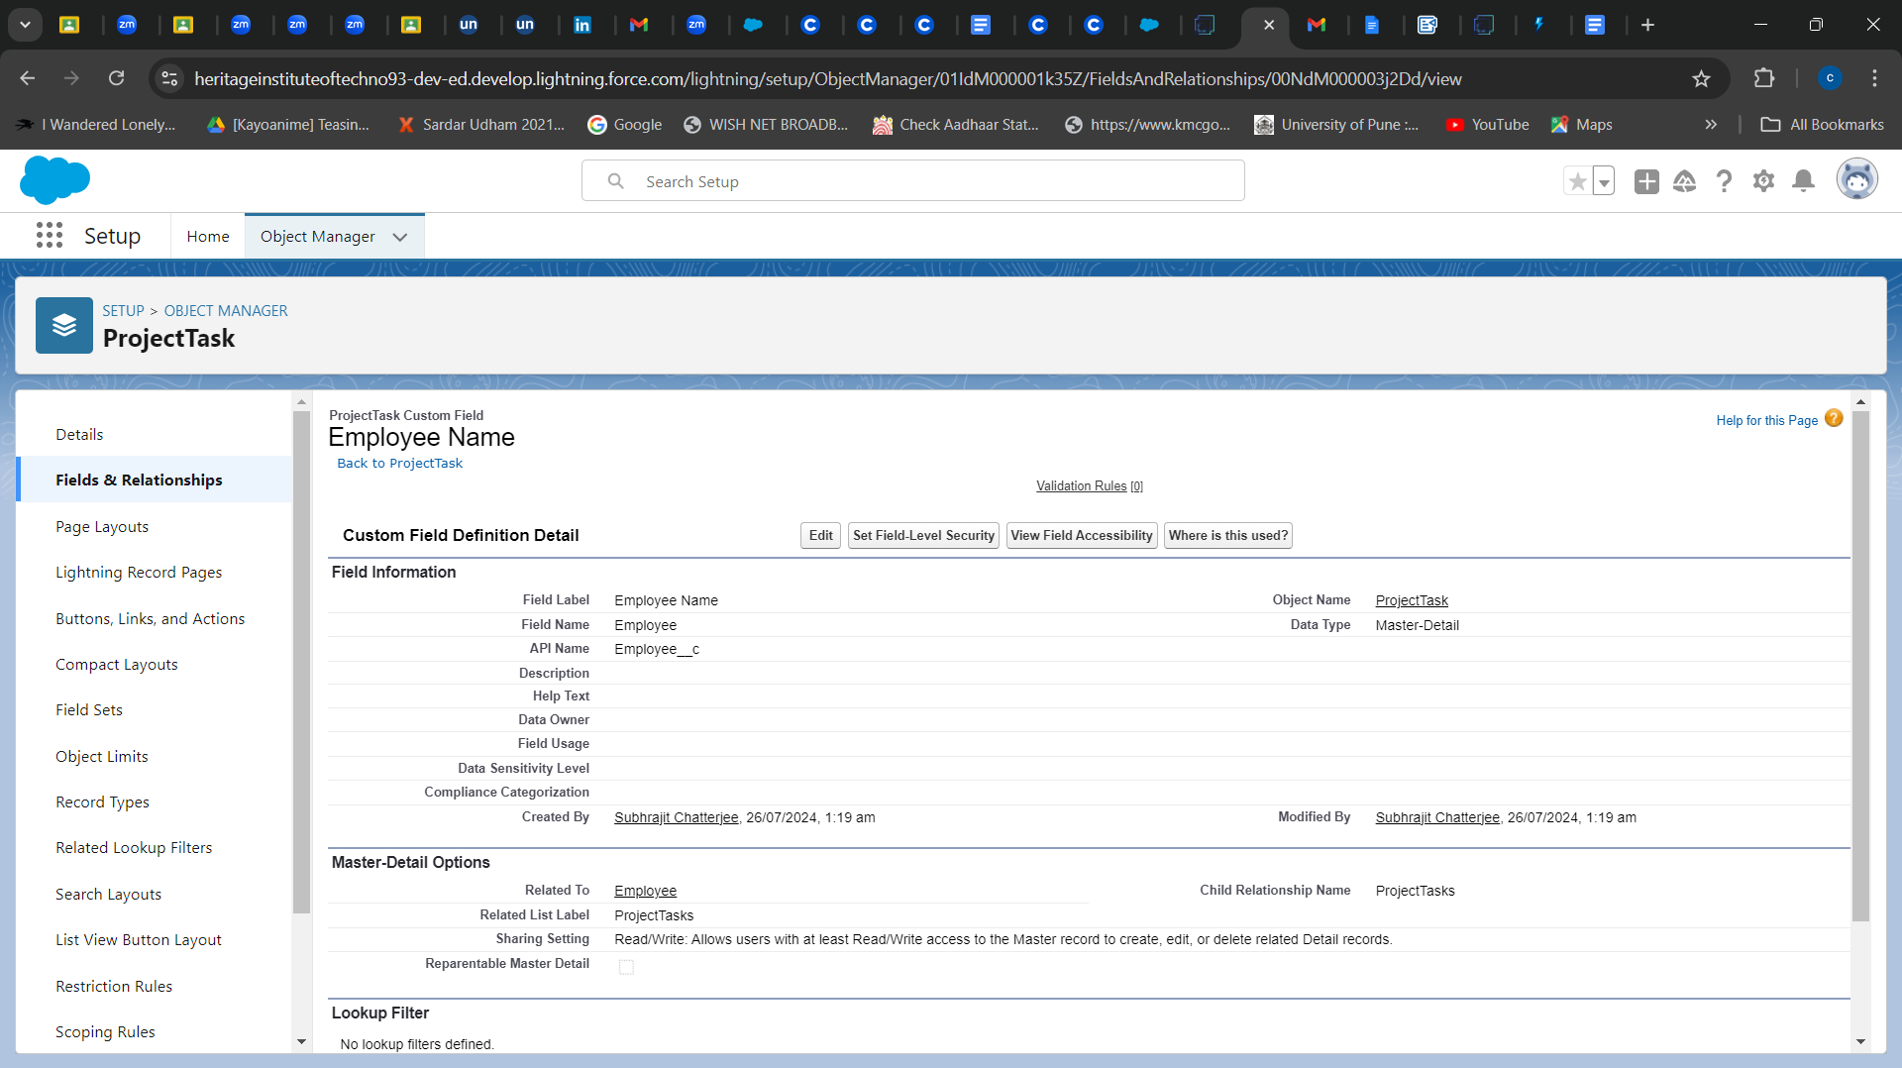

## TASK 16: **Creating Remaining Fields in Objects created**

1. Now we create the useful fields that are going to be used in objects -

Employee,Project,ProjectTask,Asset Service,Asset as per task 10 - 15.

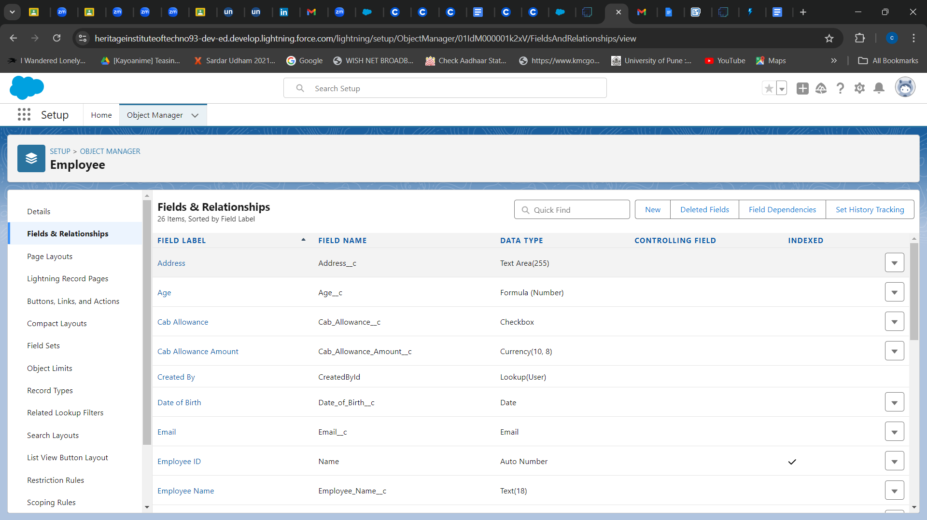

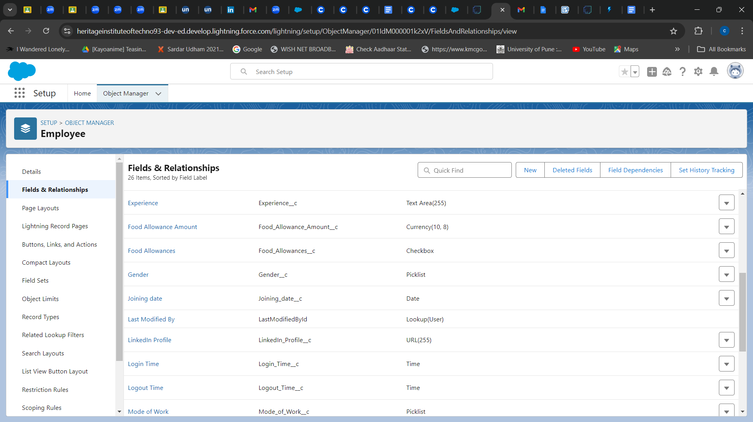

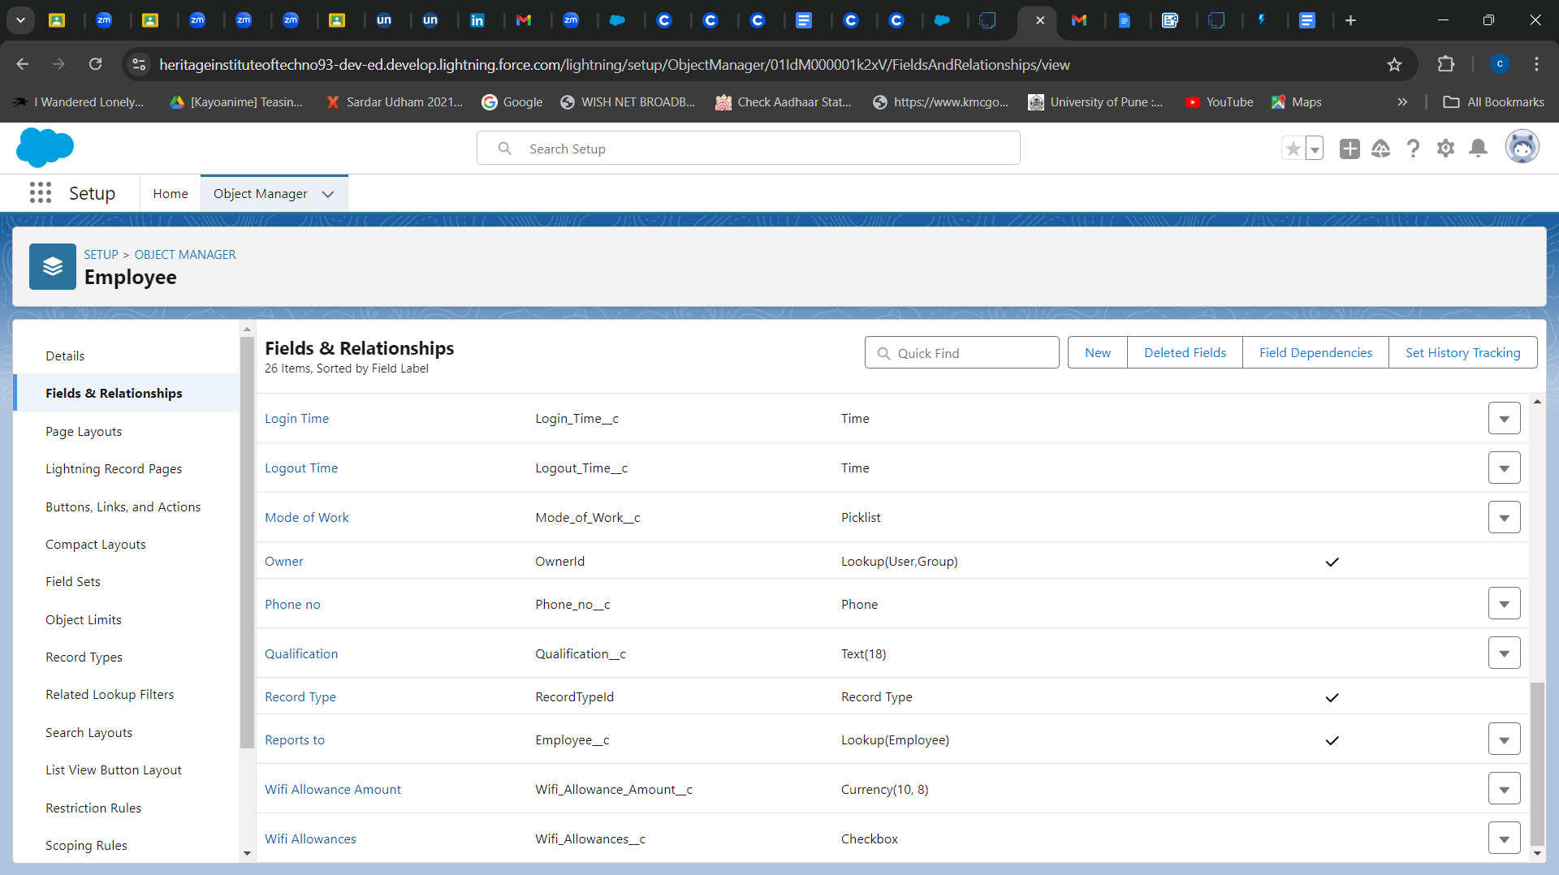

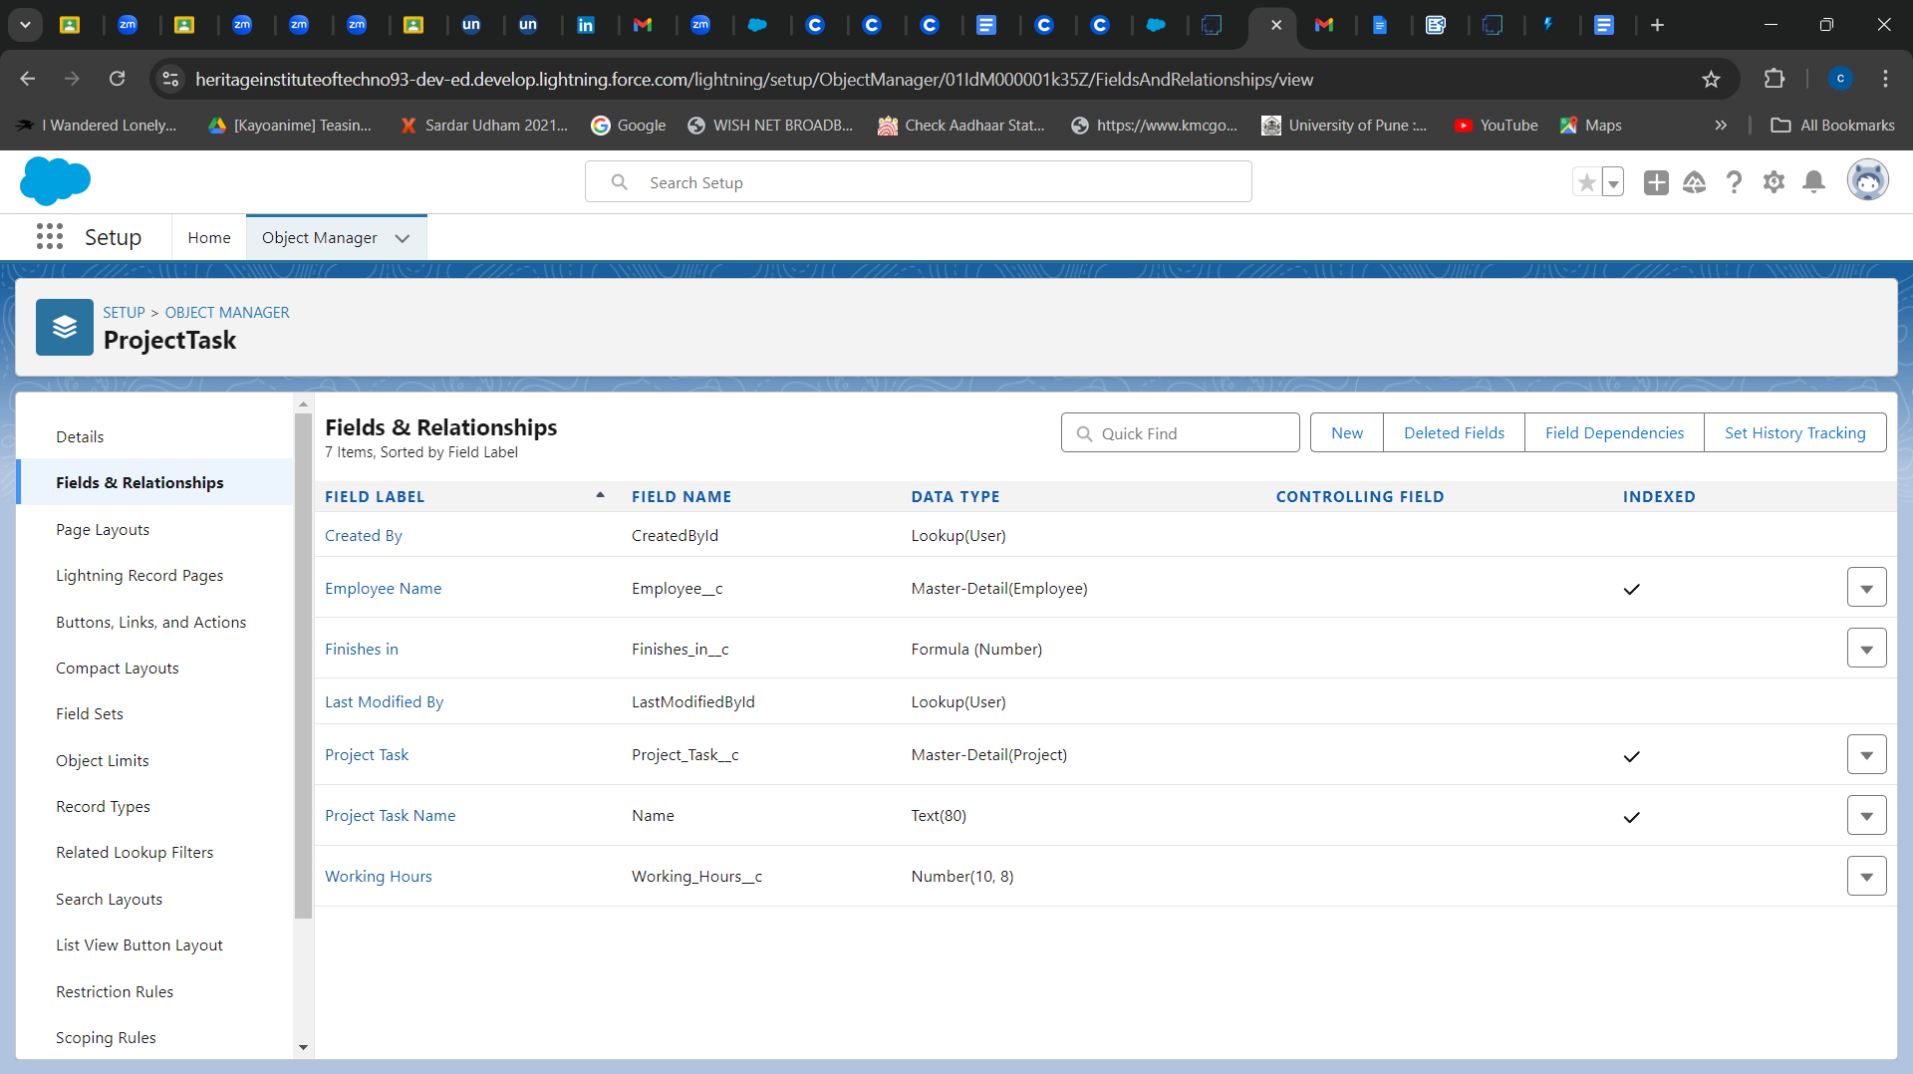

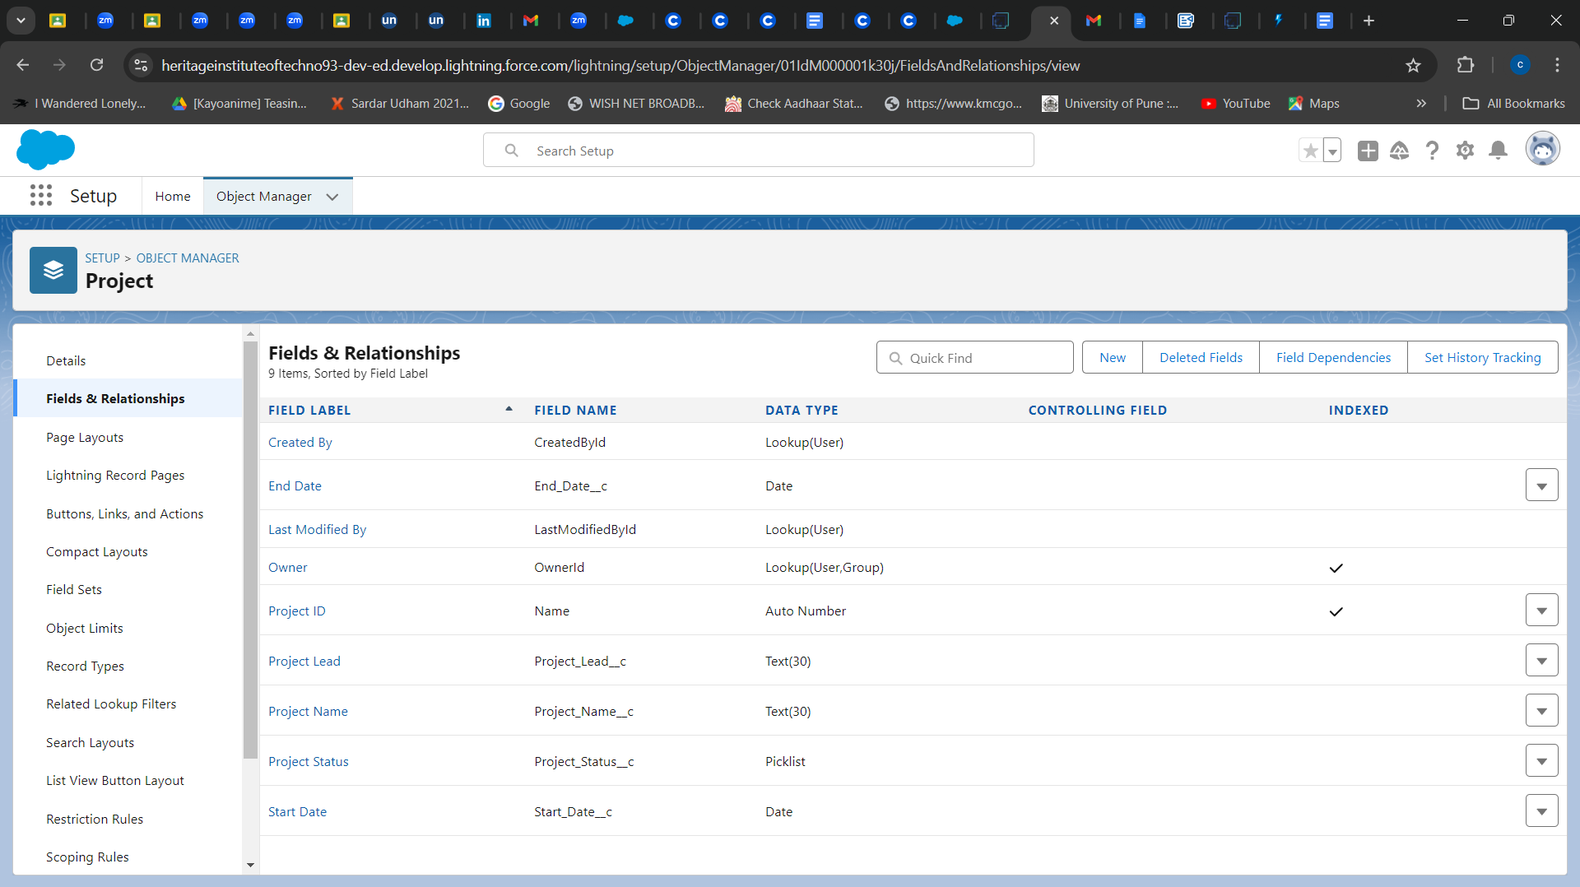

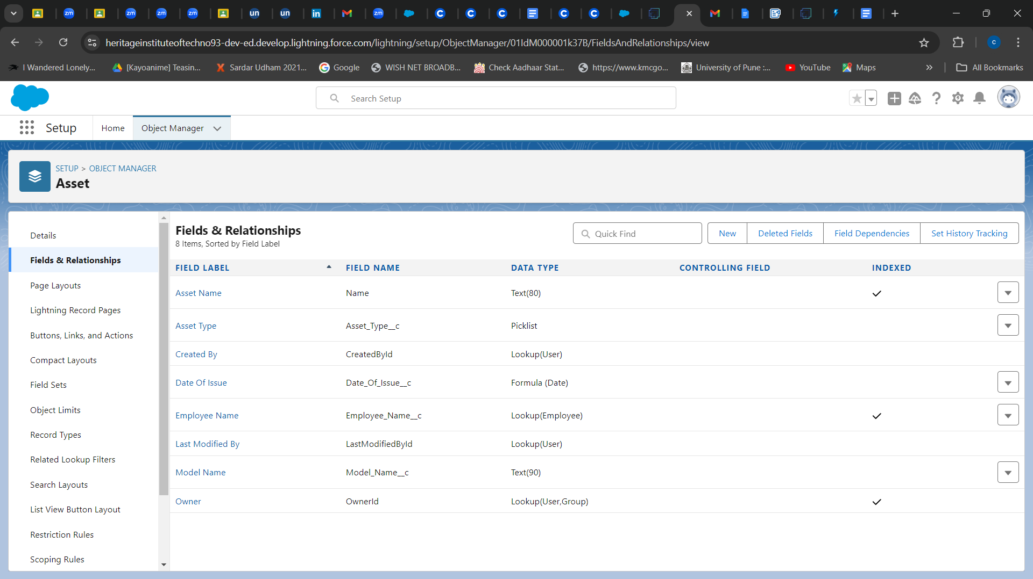

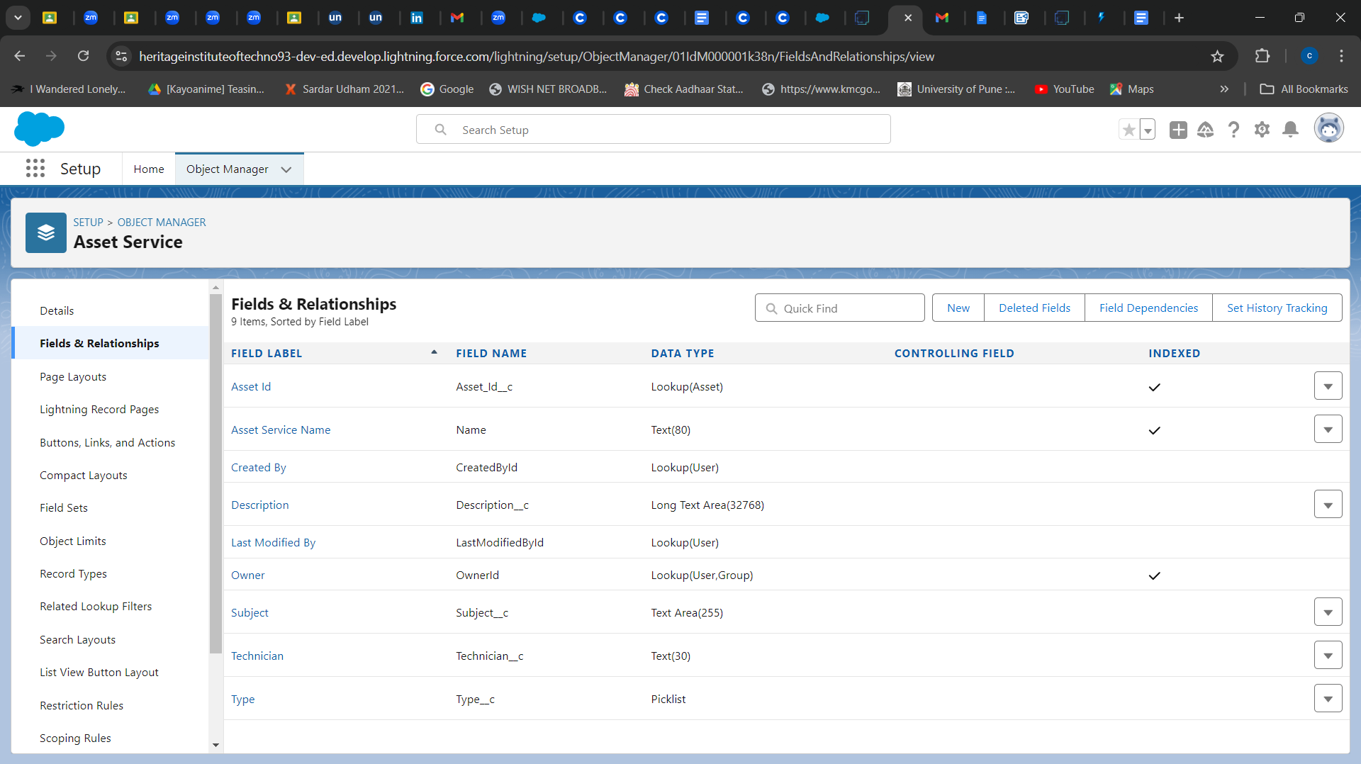

# ***Setting OWD***

## TASK 17: **Create OWD Setting**

1. Go to Set Up --> in the Quick Find box type "Sharing Settings" --> click on it.
2. Click Edit in the Organization-Wide Defaults area.
3. Search for the Employee object.
4. Under default internal access and default external access change the options to “Private” and under grant access using hierarchies select the check box.
5. Click on save.
6. This Setting is for all the Users Which have been Created.

## TASK 18: **Set OWD Setting(Project and Asset Service)**

1. We set OWD as Private for Project and Asset Service objects.

## 

# ***User Adoption***

## TASK 19: **Create a Record (Employee)**

1. Click on App Launcher on the left side of the screen.
2. Search Workforce Administration Solution & click on it.
3. Click on the Employee tab.
4. Click New.
5. Fill the Details and click on Save.

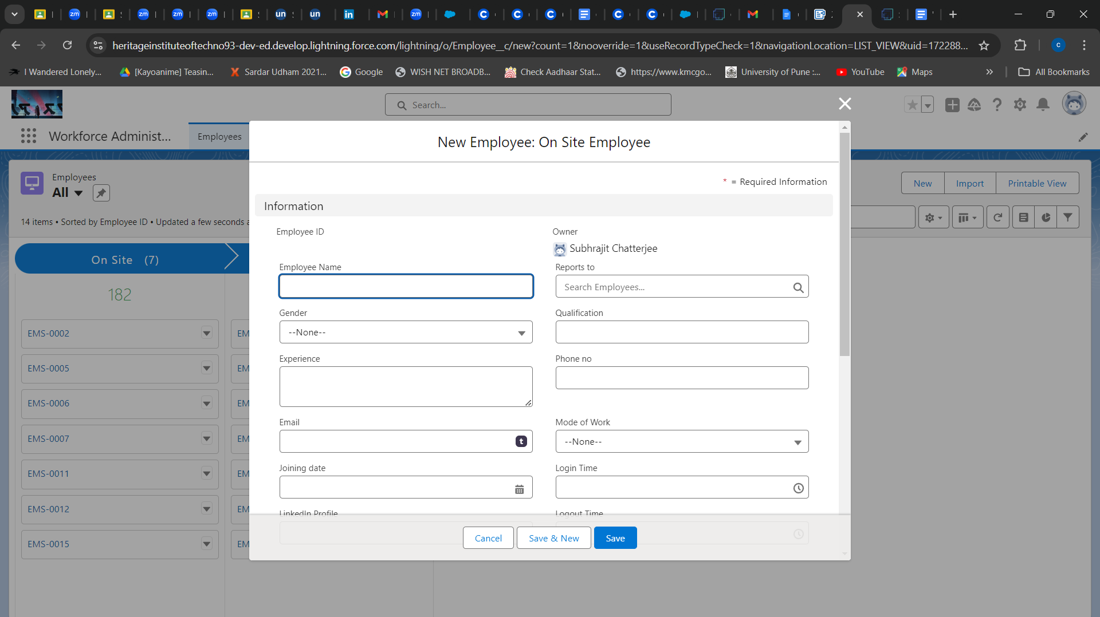

## TASK 20: **View a Record (Employee)**

1. Click on App Launcher on the left side of the screen.
2. Search Workforce Administration Solution & click on it.
3. Click on the Employee Tab.
4. 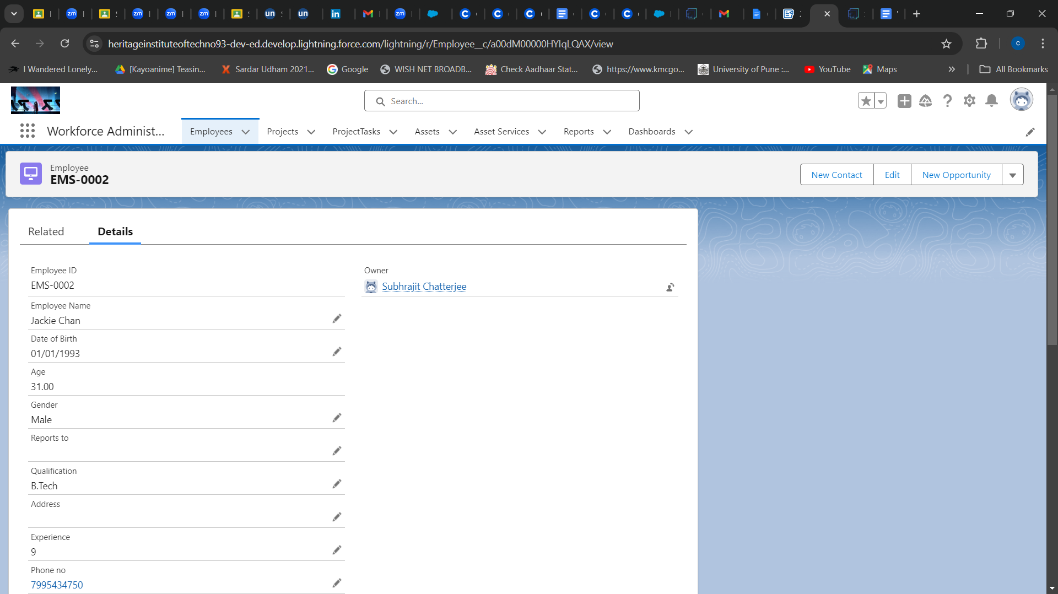Click on any record name. you can see the details of the Employee

## 

## 

## TASK 21: **Delete a Record (Employee)**

1. Click on App Launcher on the left side of the screen.
2. Search Workforce Administration Solution & click on it.
3. Click on the Employee Tab.
4. Click on Arrow at right hand side on that Particular record.
5. Click delete.

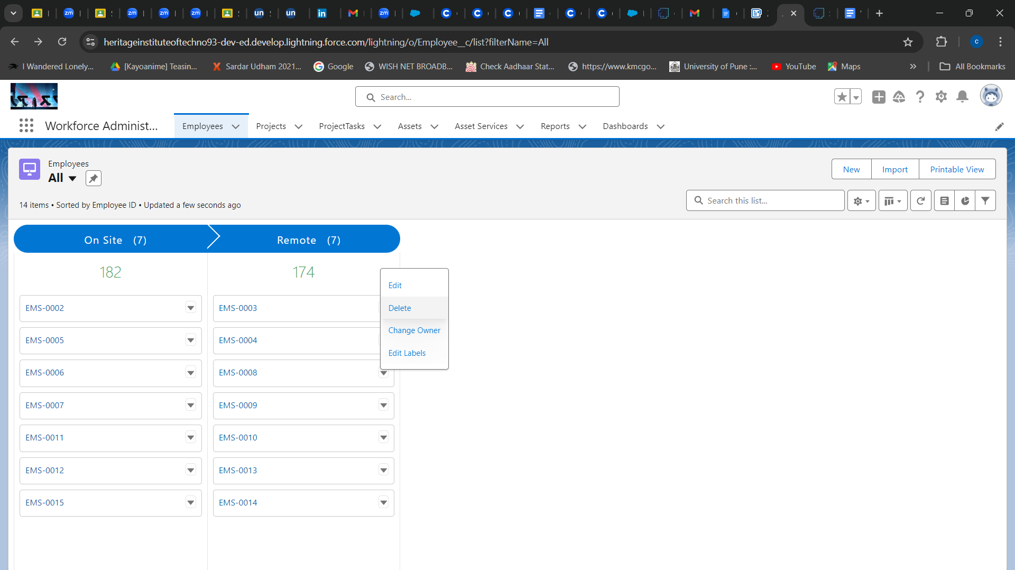

# ***Import Data***

## TASK 22: **Importing data using Data Wizard**

1. From Setup, click the Home tab.
2. In the Quick Find box, enter Data Import and select Data Import Wizard.
3. Click Launch Wizard!
4. Click the Custom Objects tab and select the Employee object.
5. Select Add new records.
6. Click CSV and choose file Employee_CSV which we made earlier. Click Next.
7. Since the field names in the CSV file (CSV Header) are the same as the field names in our object (Mapped Salesforce Object), the fields are automatically mapped. Click Next.
8. The next screen gives us a summary of our data import. Click Start Import.
9. Click OK on the popup.
10. Scroll down the page and verify that our data has been imported under batches.
11. Make sure we have 0 records under the records failed column.

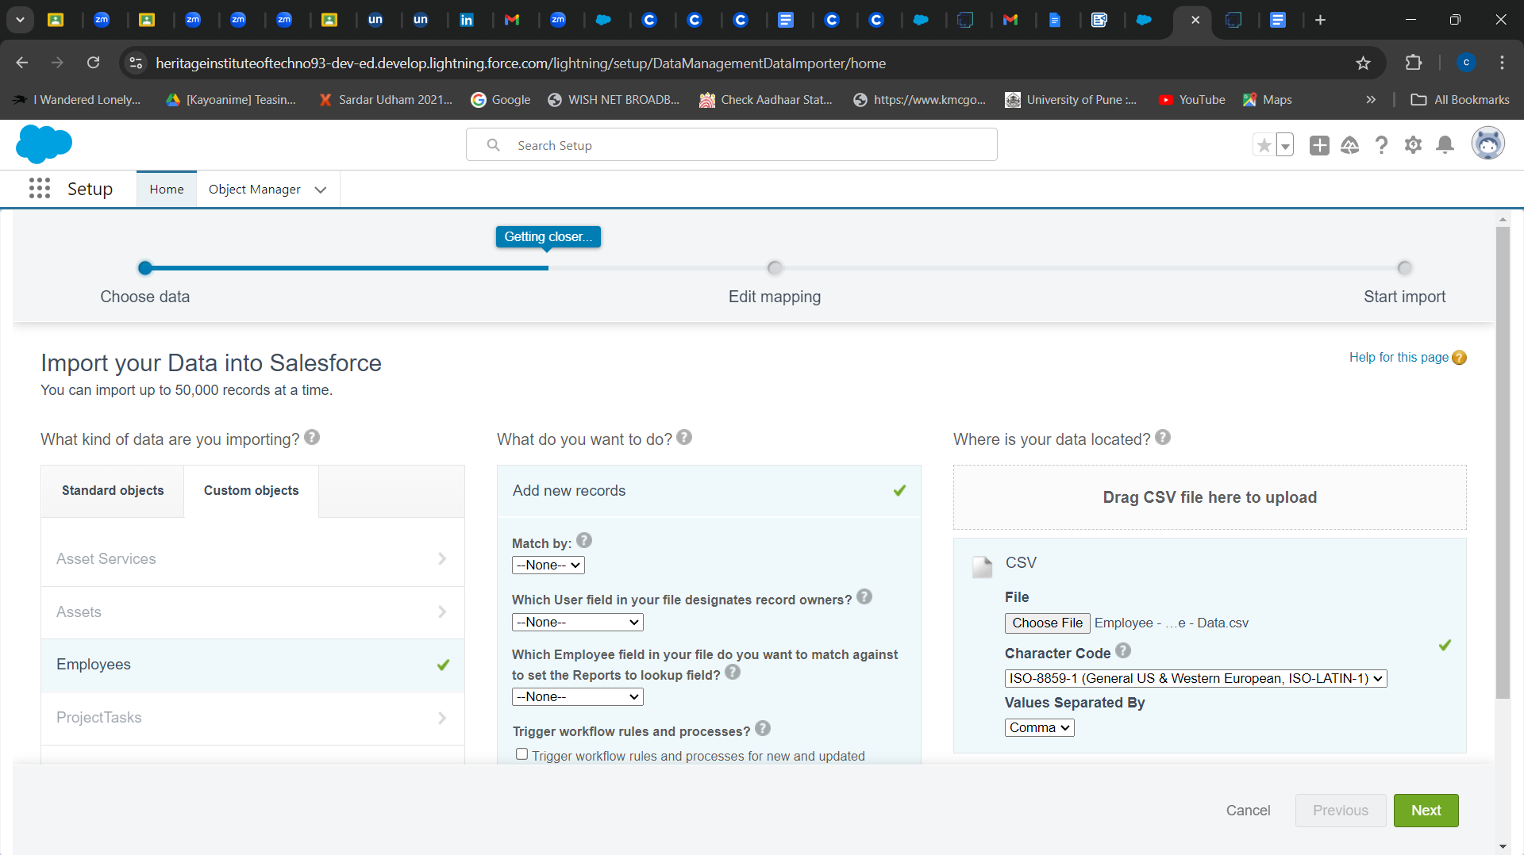

# ***Profiles***

## TASK 23: **HR Profile**

1. Go to setup --> type profiles in quick find box --> click on profiles --> clone the desired profile (Standard user) --> enter profile name (HR) --> Save.
2. While still on the profile page, then click Edit.
3. Scroll down to Custom Object Permissions and Give access permissions for Assets and Asset Services objects.
4. Scroll down and Click on Save.

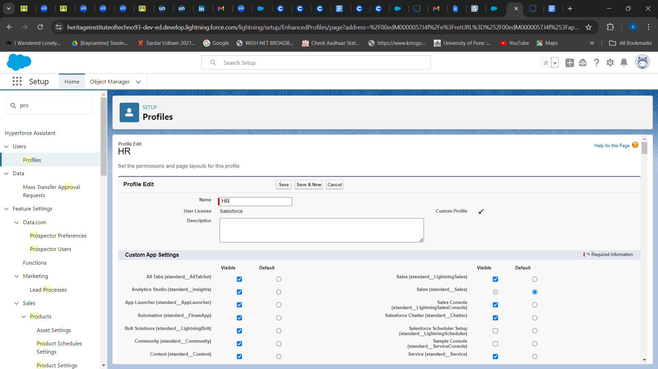

## TASK 24: **Manager Profile**

1. Go to setup --> type profiles in quick find box --> click on profiles --> clone the desired profile (Salesforce Platform User) --> enter profile name (Manager) --> Save.
2. While still on the profile page, then click Edit.
3. Scroll down to Custom Object Permissions and Give access permissions for Employee, Project and Project Task objects.
4. Scroll down and Click on Save.

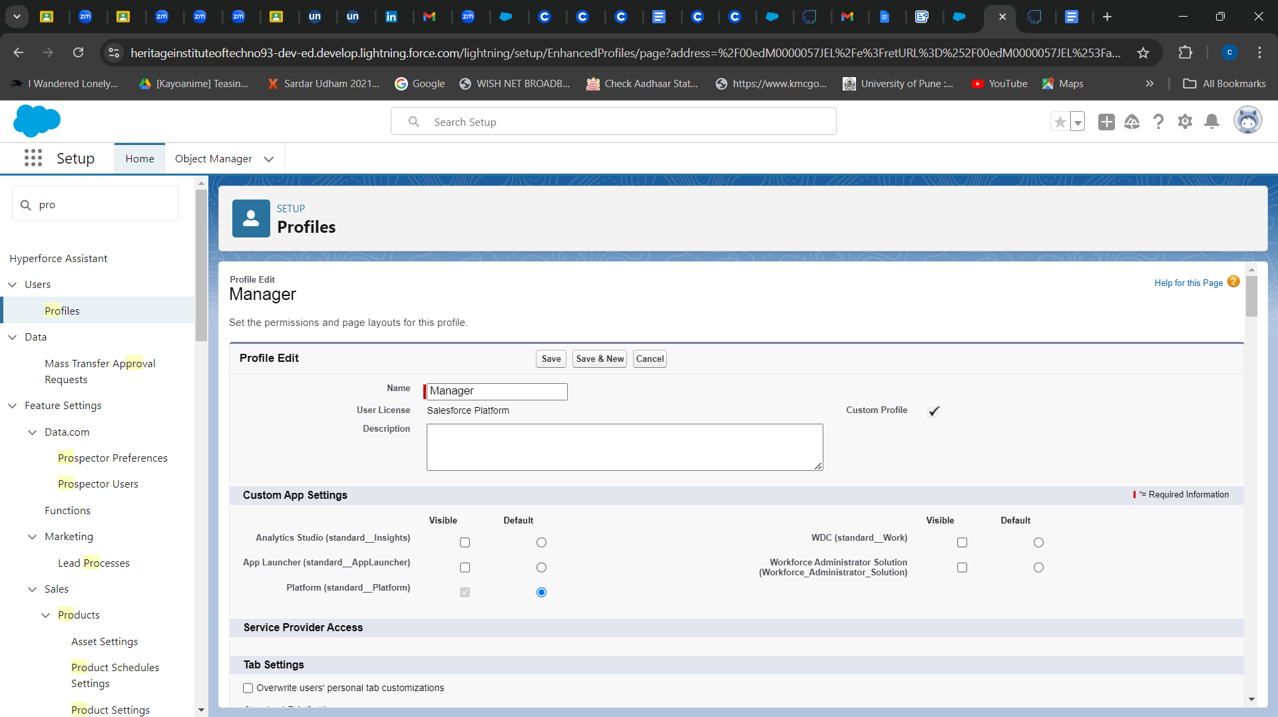

## 

## TASK 25: **On Site Employee Profile**

1. Go to setup --> type profiles in quick find box --> click on profiles --> clone the desired profile (Salesforce Platform User) --> enter profile name (On Site Employee) --> Save.
2. While still on the profile page, then click Edit.
3. Scroll down to Custom Object Permissions and Give access permissions for Project and Project Task objects.
4. Scroll down and Click on Save.

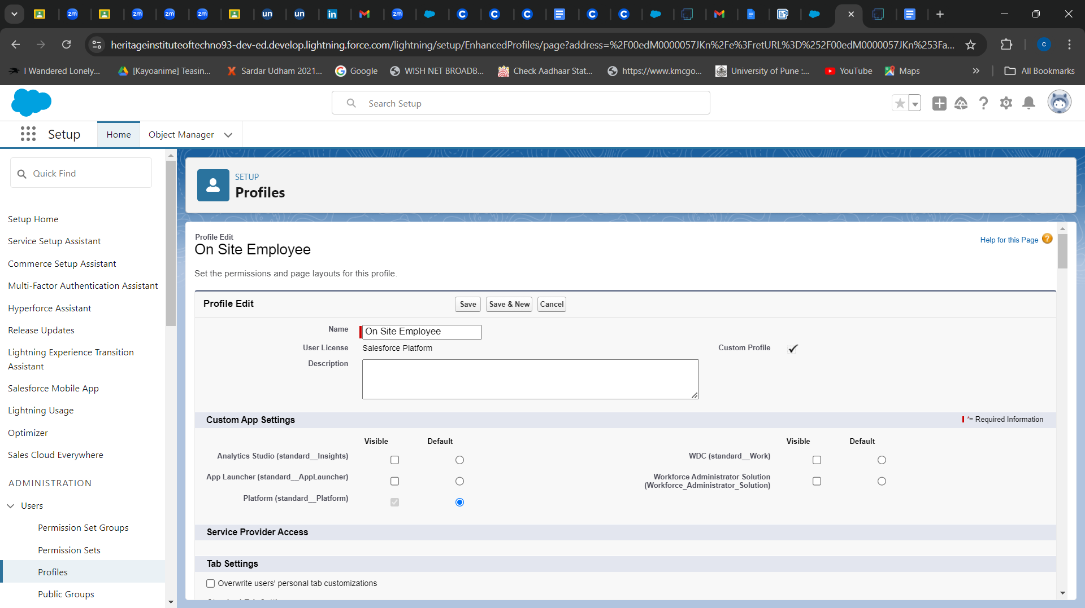

## 

## TASK 26: **Remote Employee Profile**

1. Go to setup --> type profiles in quick find box --> click on profiles --> clone the desired profile (Salesforce Platform User) --> enter profile name (Remote Employee) --> Save.
2. While still on the profile page, then click Edit.
3. Scroll down to Custom Object Permissions and Give access permissions for Project and Project Task objects.
4. Scroll down and Click on Save.

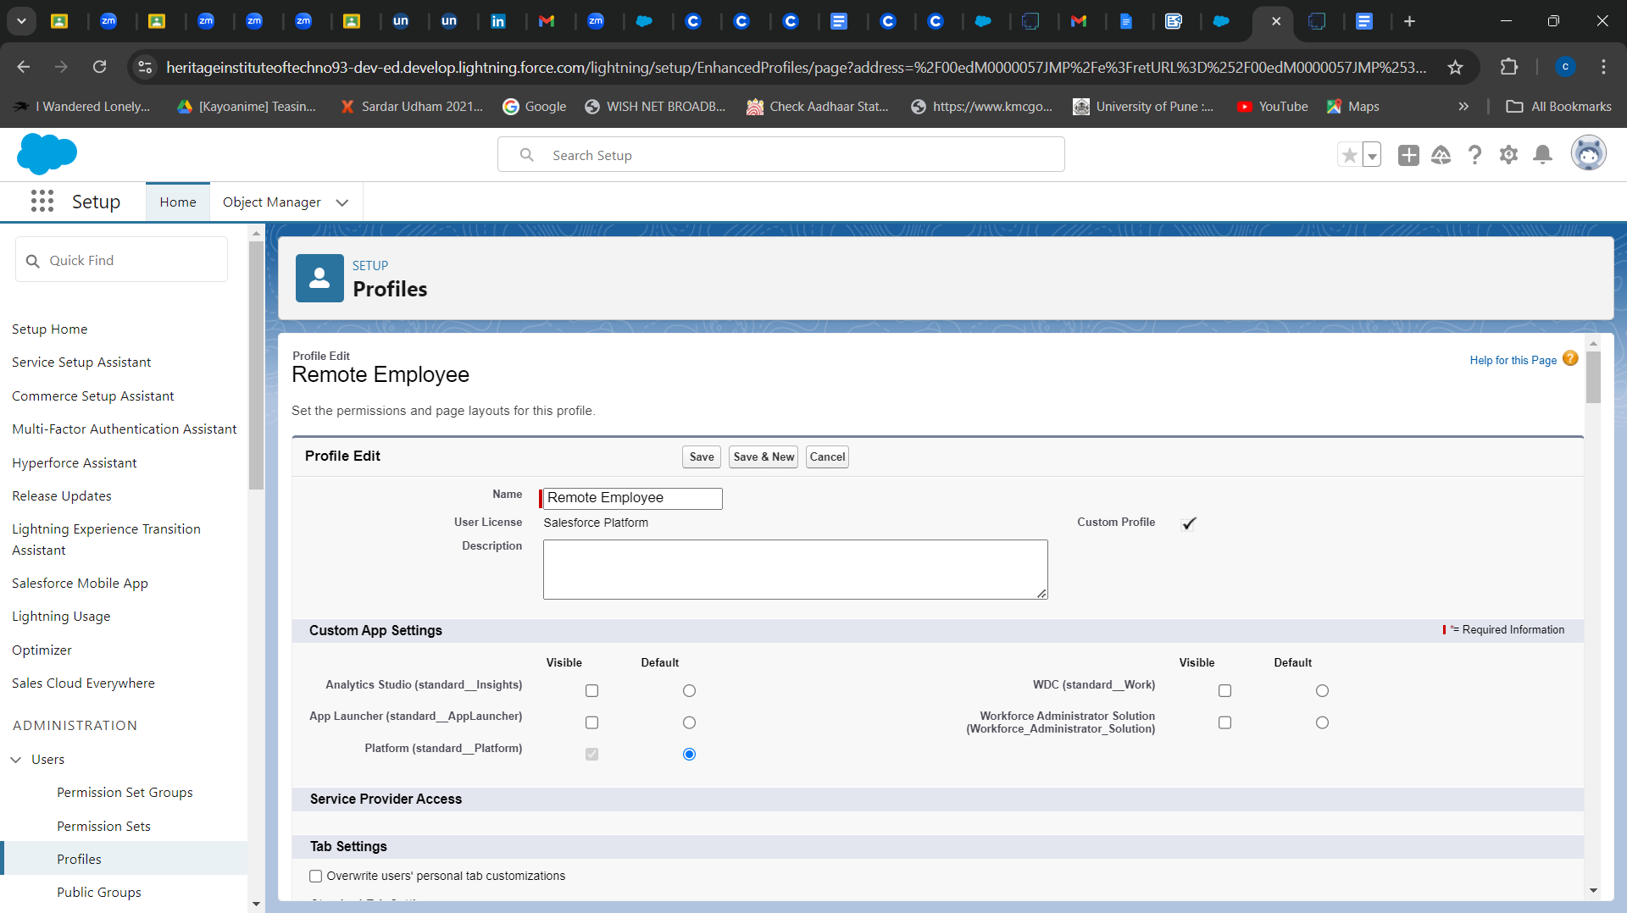

# ***Role***

## TASK 27: **Creating HR Role**

1. Go to quick find --> Search for Roles --> click on set up roles.
2. Click on Expand All and click on add role under whom this role works.
3. Give Label as “HR” and Role name gets auto populated. Check to whom this role (HR) reports which is CEO. Then click on Save.

## TASK 28: **Creating more roles**

1. We create roles for Manager, On Site Employee, Remote Employee according to task 27.

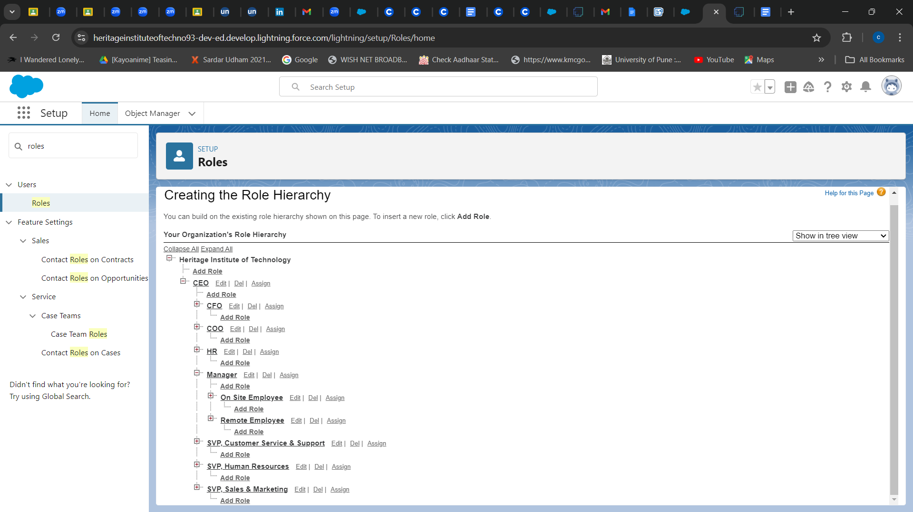

# ***Users***

## TASK 29: **Create User(HR)**

1. Go to setup --> type users in quick find box --> select users --> click New user.
2. Fill up the details(Role-HR,User license-Salesforce,Profile-HR).
3. Save.

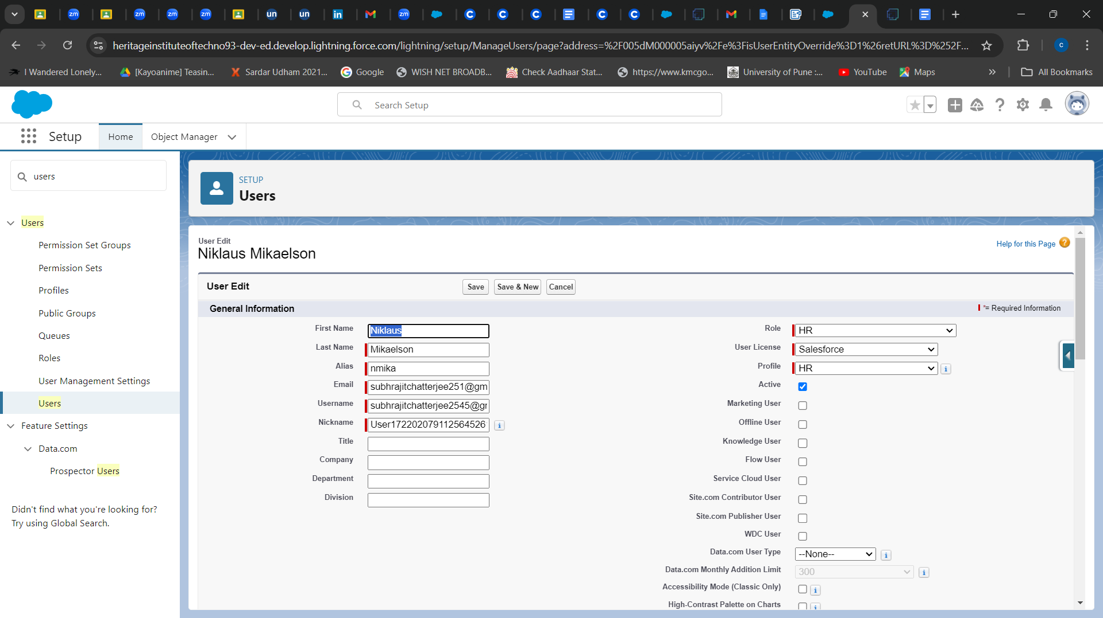

## TASK 30: **Create User(Manager)**

1. Go to setup --> type users in quick find box --> select users --> click New user.
2. Fill up the details(Role-Manager,User license-Salesforce Platform,Profile-Manager).
3. Save.

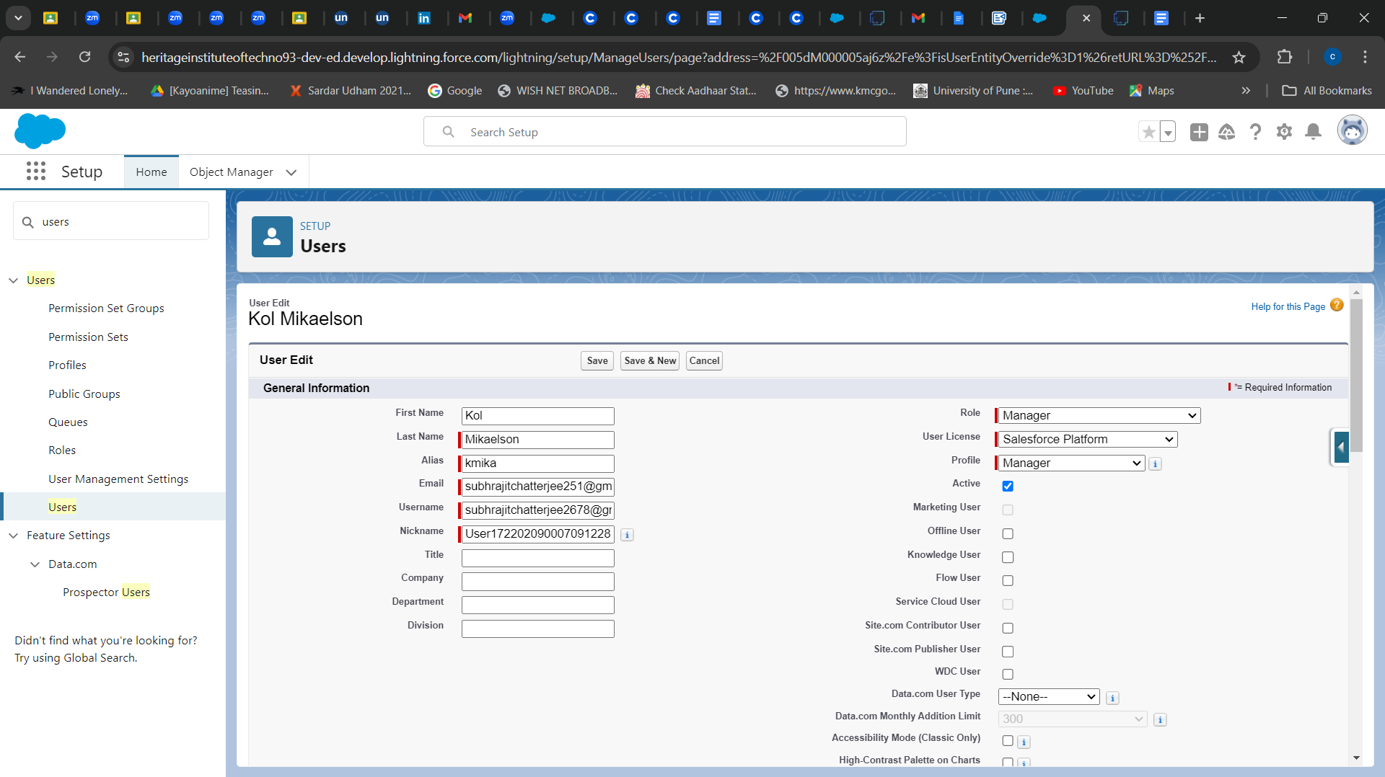

## TASK 31: **Create More Users**

1. We create two users for remote employee and on-site employee according to task 30.

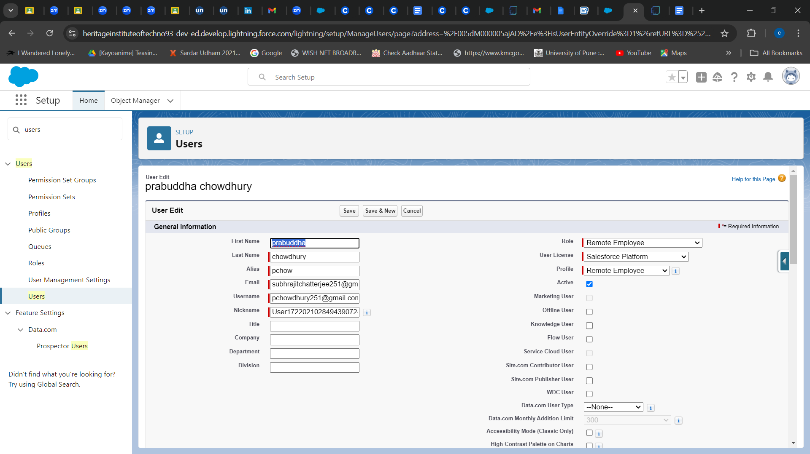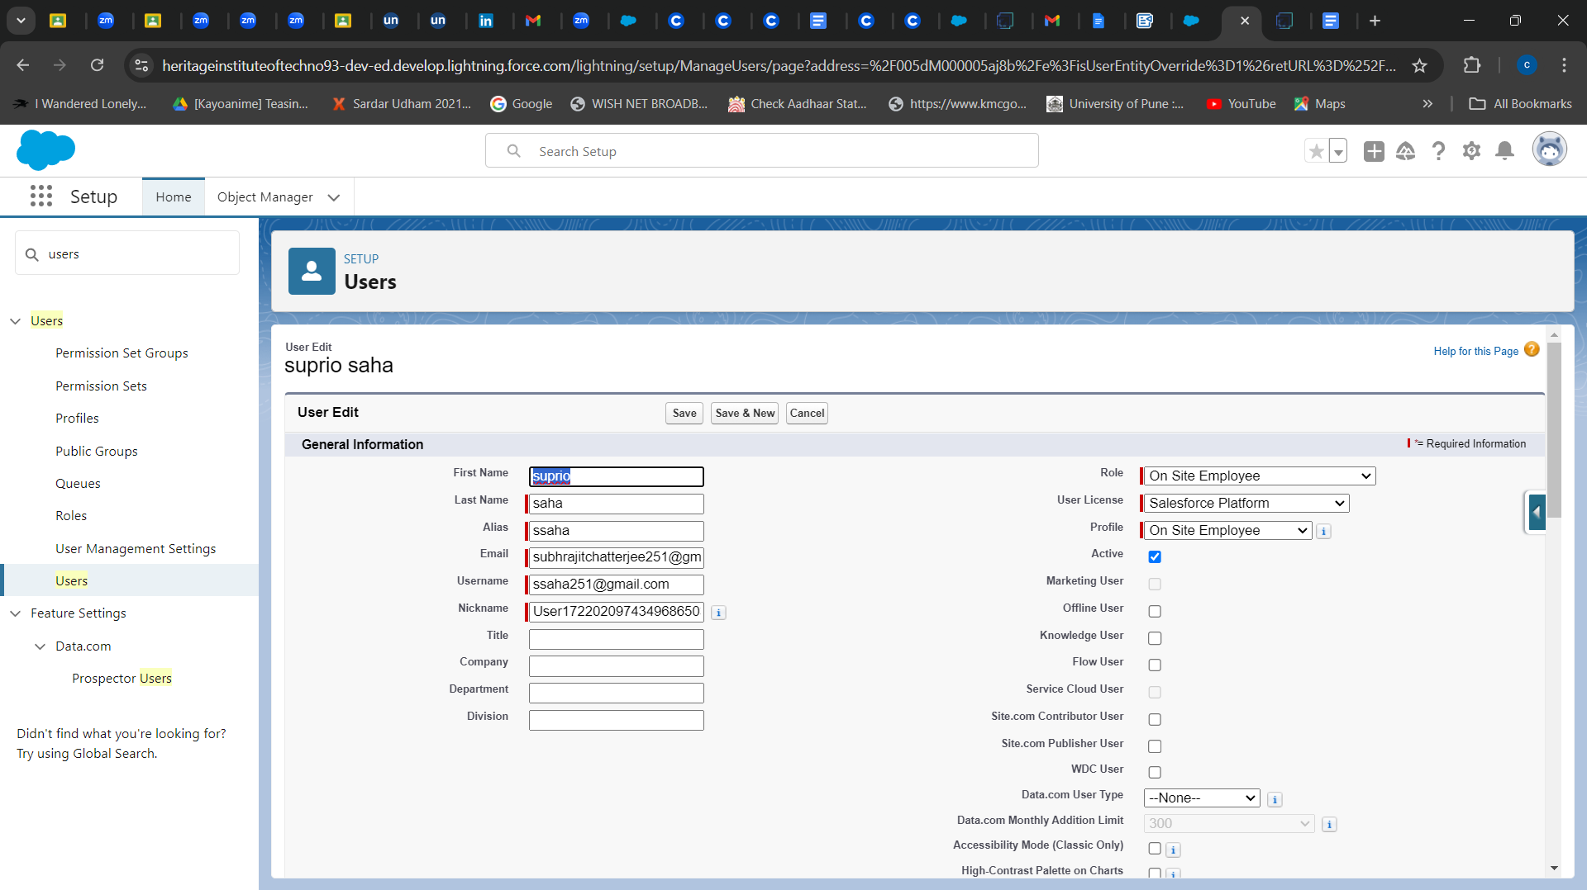

# ***Page Layouts***

## TASK 32: **creating a page layout for Employee object**

1. Go to Setup --> Click on Object Manager --> Search for the object (Employee) --> From drop down click on Edit.
2. Click on Page layout --> Click on New.
3. Give Page layout Name as “On Site Employee Layout” and click on Save.
4. Drag and drop the Section from the highlight panel below the Information and name it as “Personal Information” and click Ok.
5. Drag Date of Birth, Address and Age fields from Employee Information to Personal Information section.
6. Similarly perform the above step to create “Allowances” and add allowances fields in it as shown below.
7. Click Save.

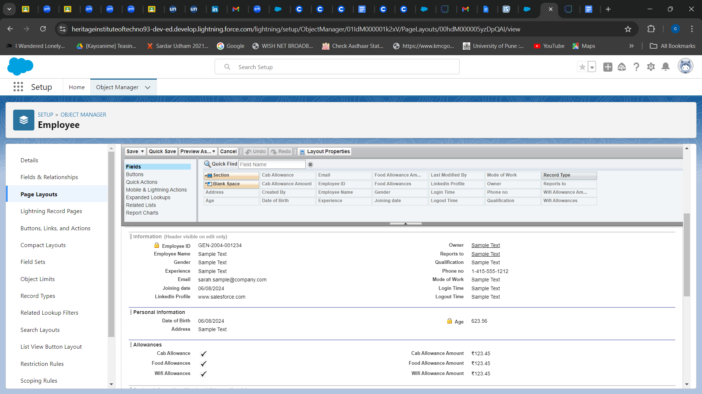

## TASK 33: **creating another page layout for Employee object**

1. We create another page layout and name it as “Remote Employee Layout”, and in the allowances section use only Wifi Allowance and Wifi Allowances Amount fields according to task 32.

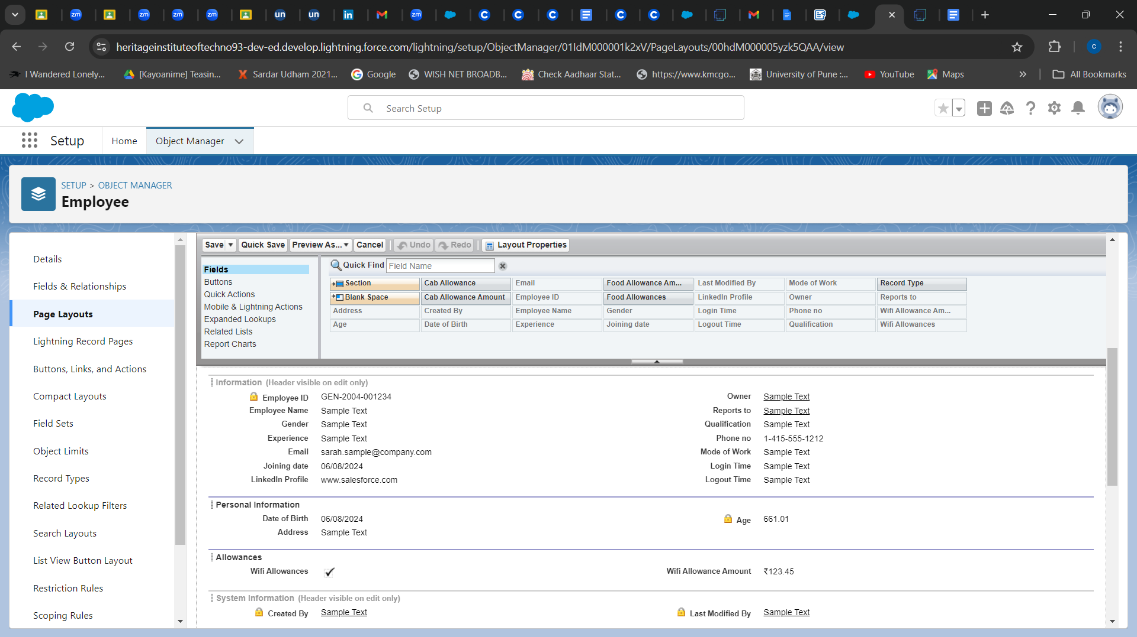

# ***Chatter Groups***

## TASK 34: **Creating a chatter group for your organization**

To Create a chatter group:

1. Click the App Launcher.
2. Enter Groups in the Search apps and items... box and select Groups.
3. Click New.
4. Fill in the new group information( Group Name -Internal Discussion,Access Type - Private, Allow Customers - Checked)
5. Click Save & Next. Skip the Upload Picture section and click Next.
6. On the Manage Members screen, click Add next to users we created in the previous activity.
7. Click Done.
8. This is how our group interface looks like.

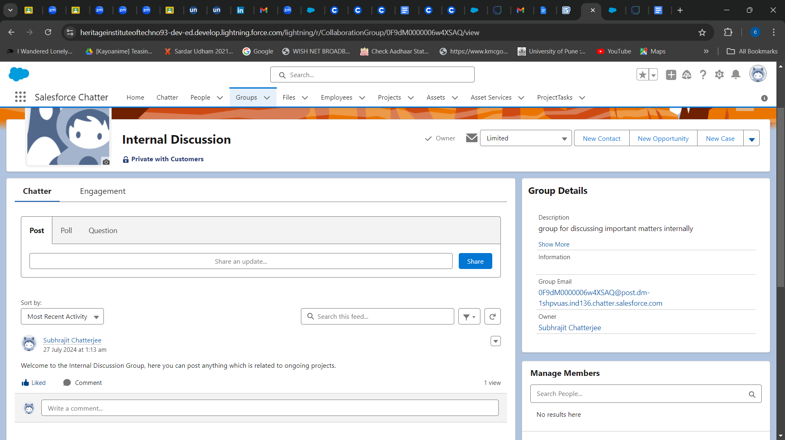

1. Where it says Share an update, post this message to the group: Welcome to the Internal Discussion Group, here you can post anything which is related to ongoing projects.
2. Click Share.

# ***Record Types***

## TASK 35: **Creating On Site Employee Record Type**

To create a Record Type:

1. Go to Setup --> click on Object Manager --> Search for the object (Employee) --> from drop down click Edit.

2. From the left panel click Record Types --> New.

3. Give Record Type Label as “On Site Employee” and make it active.

4. Uncheck for “Make Available”.

5. Scroll down and check for the Manager & System Administrator profile and click on Next.

6. Select “Apply a different layout for each profile”, and change page layout to On Site Employee Layout for manager profile and System Administrator.

7. click Save.

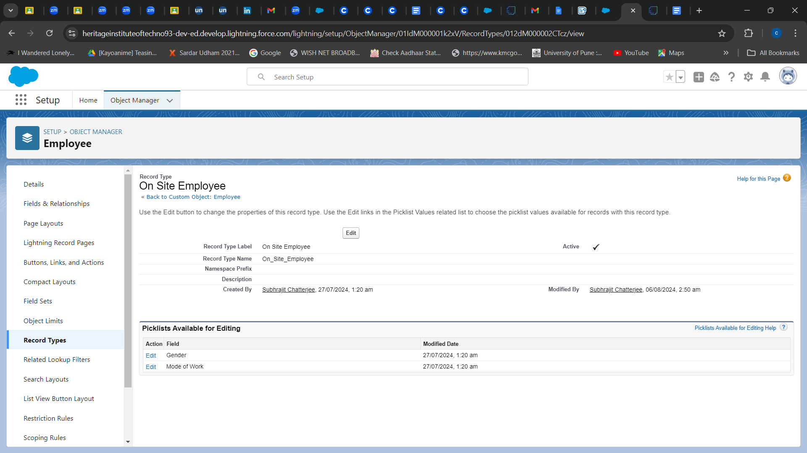

## TASK 36: **Creating Remote Employee Record Type**

1. Go to Setup --> click on Object Manager --> Search for the object (Employee) --> from drop down click Edit.

2. From the left panel click Record Types --> New.

3. Give Record Type Label as “Remote Employee” and make it active.

4. Uncheck for “Make Available”.

5. Scroll down and check for the Manager & System Administrator profile and click on Next.

6. Select “Apply a different layout for each profile”, and change page layout to Remote Employee Layout for manager profile and System Administrator.

7. click Save.

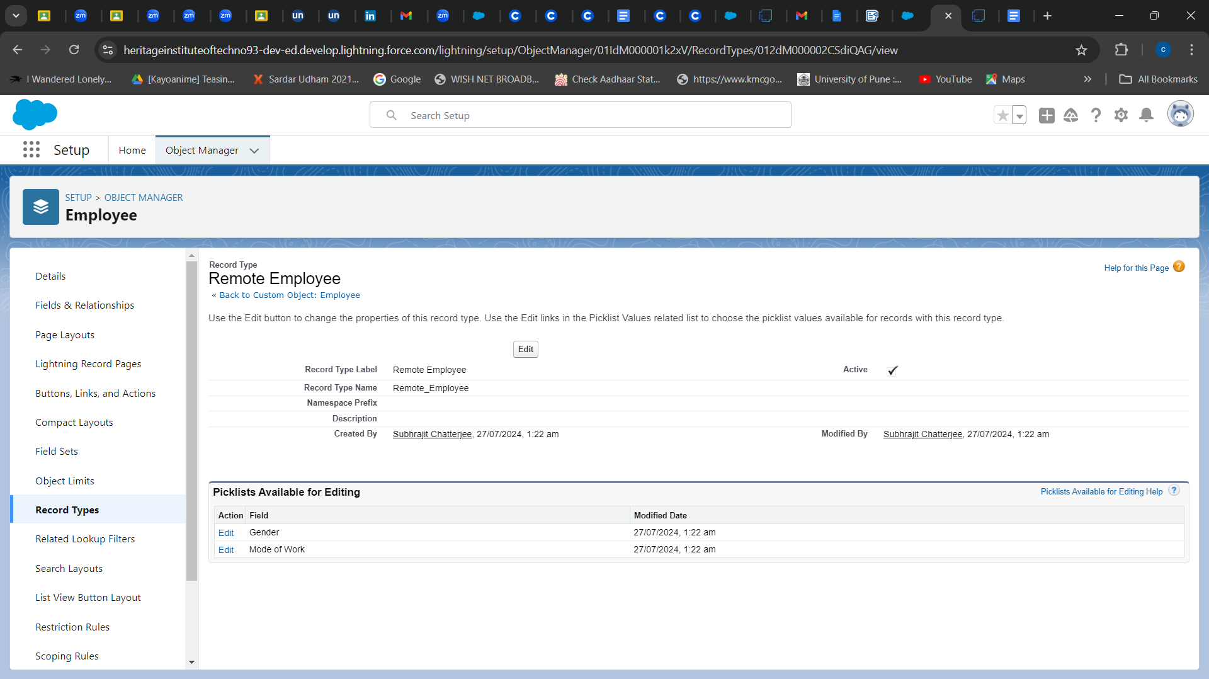

# ***Permission Sets***

## TASK 37: **Creating a permission set**

To Create a Permission Set:

1. Go to setup --> type “permission sets” in quick search --> select permission sets --> New.

2. Enter the label name as “Per to Emp” --> Save.

3. Under Apps Select object settings.

4. Click on Employee object --> click on Edit --> under object permission check for read and create.

5. Click on Save.

6. After saving the permission click on the Manage assignment

7. Now click on the Manage Assignment.

8. Click on Add Assignment.

9. Now select the users(any one user with the profile “On Site Employee”) and click on Next.

10. Click on Assign

11. Click on Done.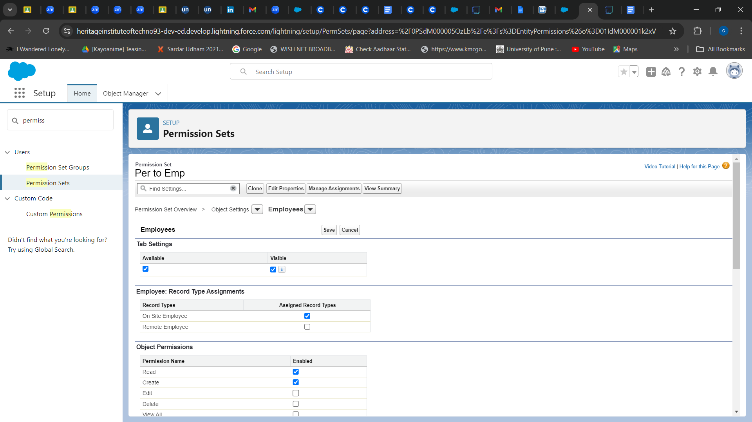

## 

# ***Reports***

## TASK 38: **Create Report**

To Create a Report:

1. Go to the app --> click on the reports tab
2. Click New Report.
3. Select report type from category or from report type panel or from search panel --> click on start report.
4. Customize your report
5. Save or run it.

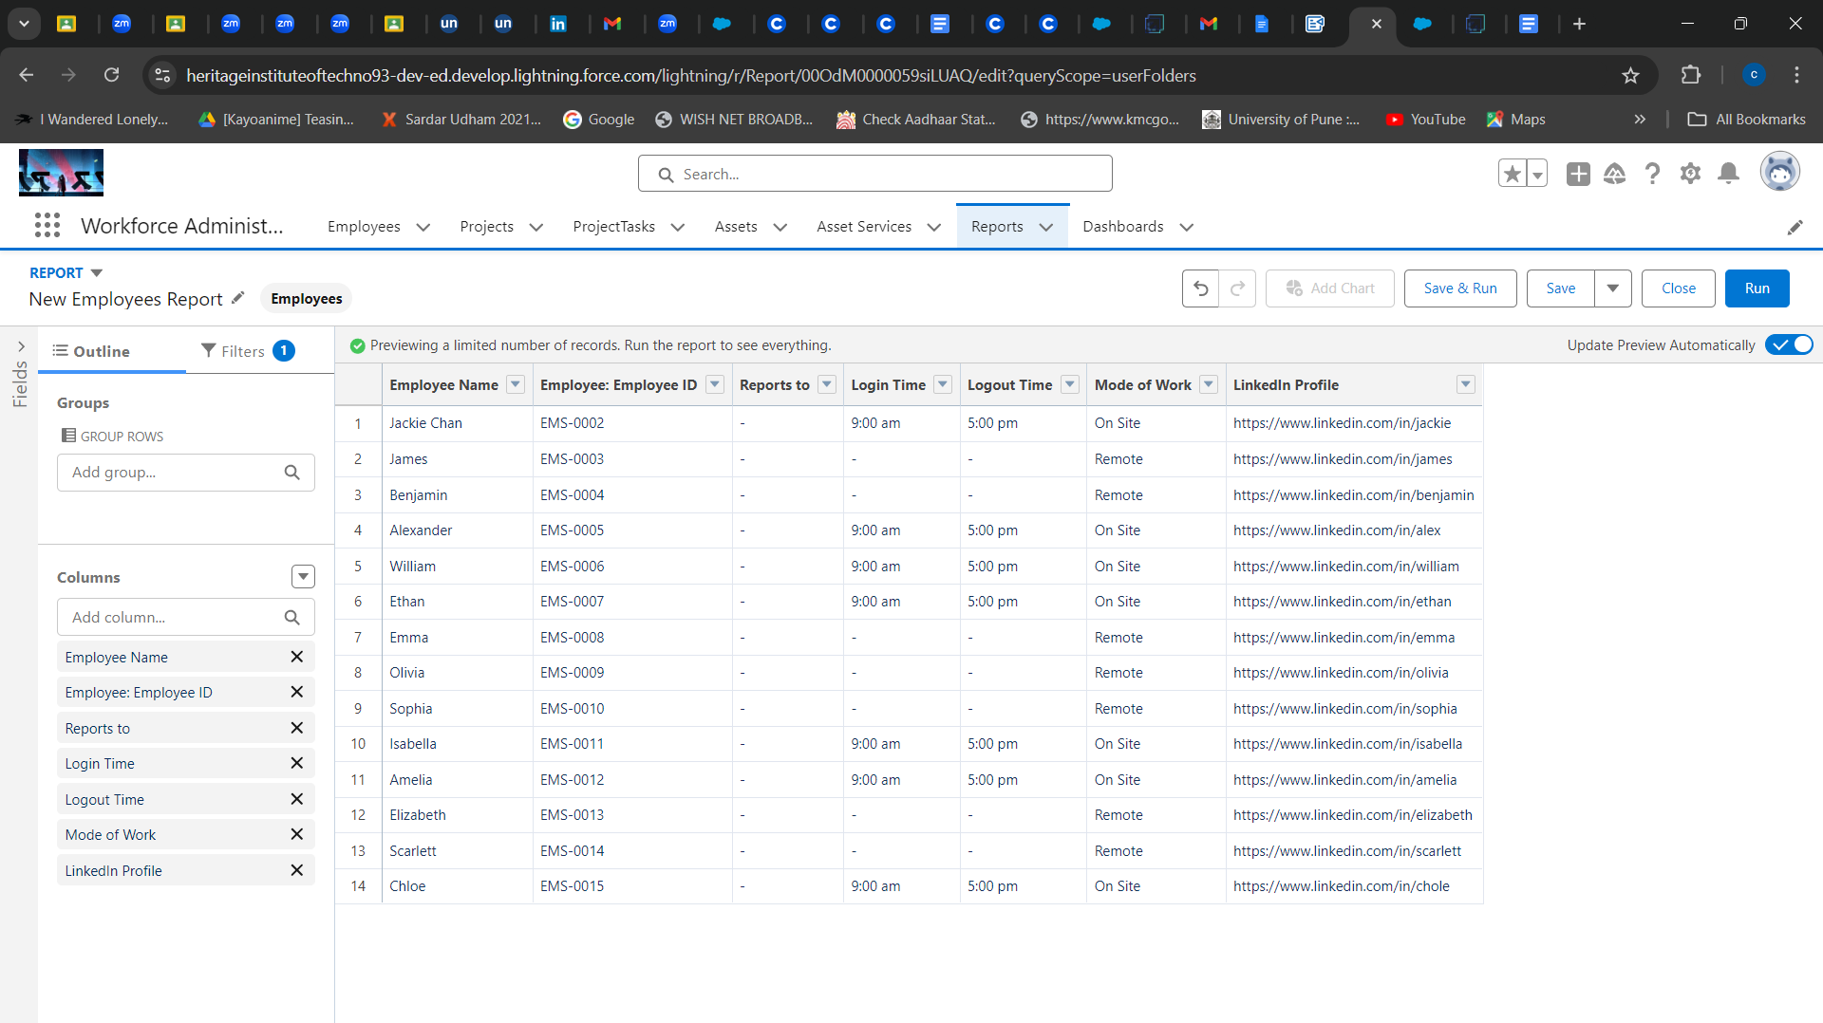

## 

## TASK 39: **Create 2 more Report**

1. We create a report with report type: “Employees with ProjectTasks and Projects”.
2. We create a report with report type: “Employees with Assets”.

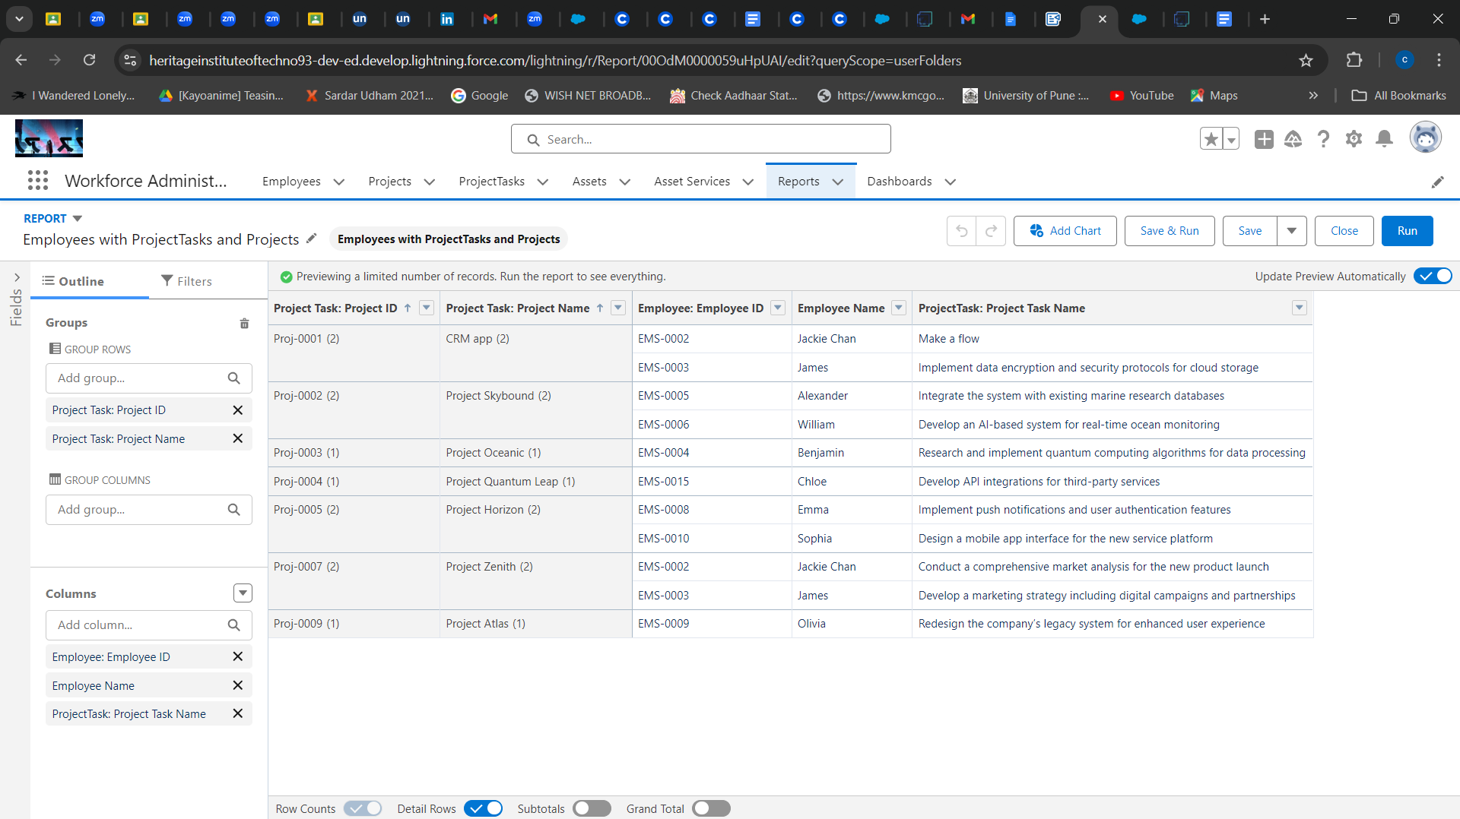

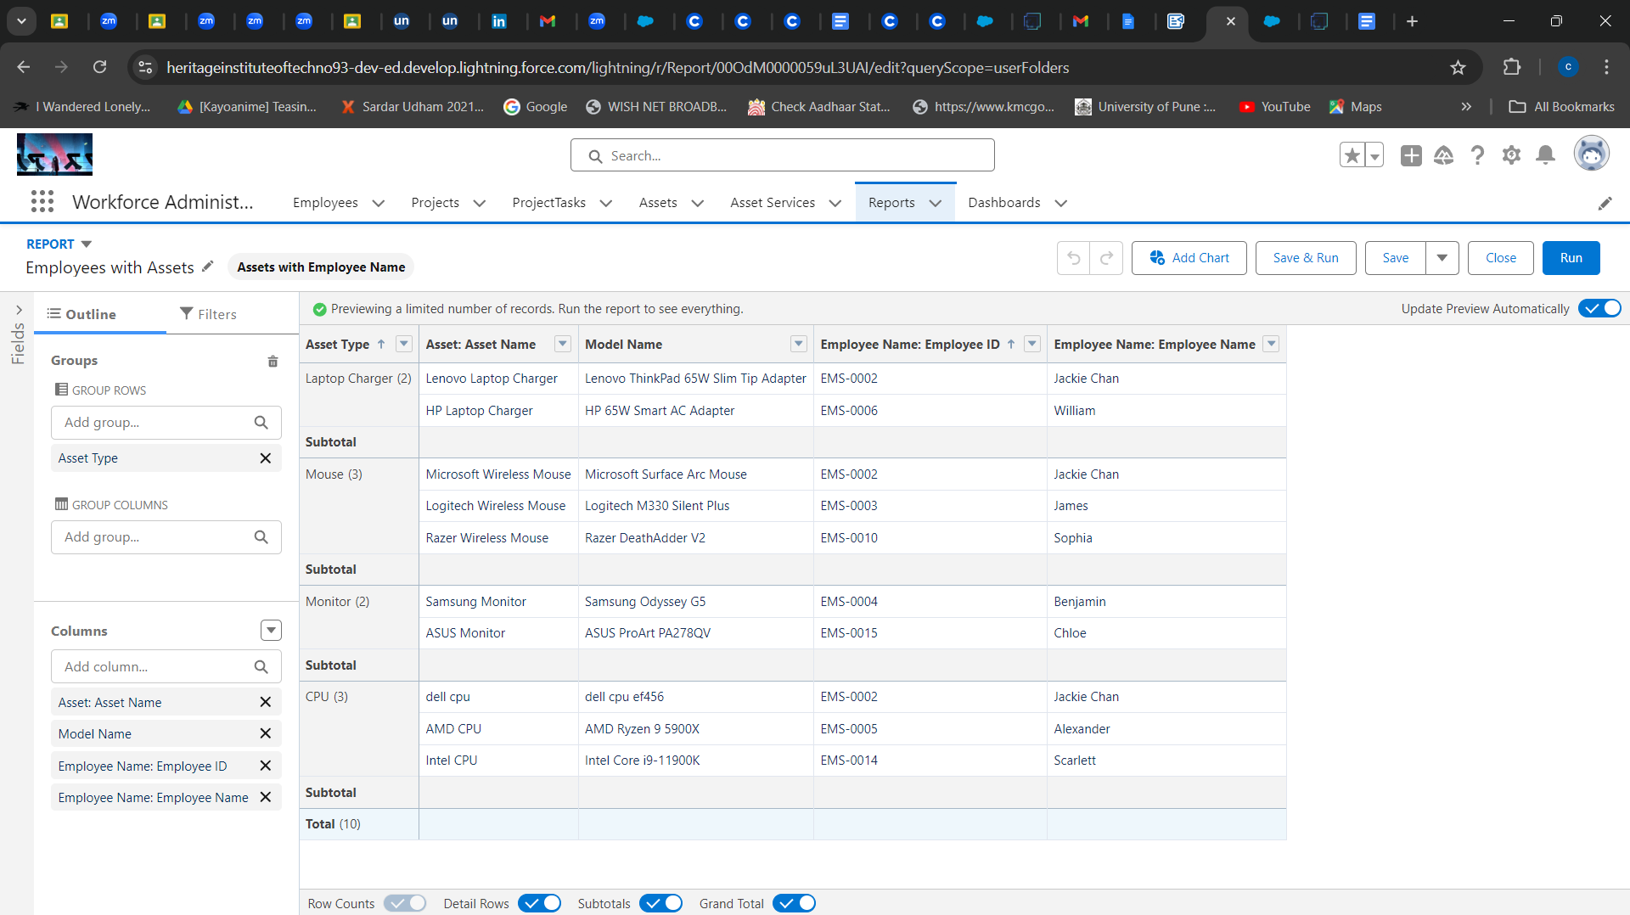

# ***Dashboards***

## TASK 40: **Create Dashboard**

To Create a Dashboard

1. Go to the app --> click on the Dashboards tabs.

2. Give a Name and click on Create.

3. Select add component.

4. Select a Report and click on select.

5. Click Add then click on Save and then click on Done.

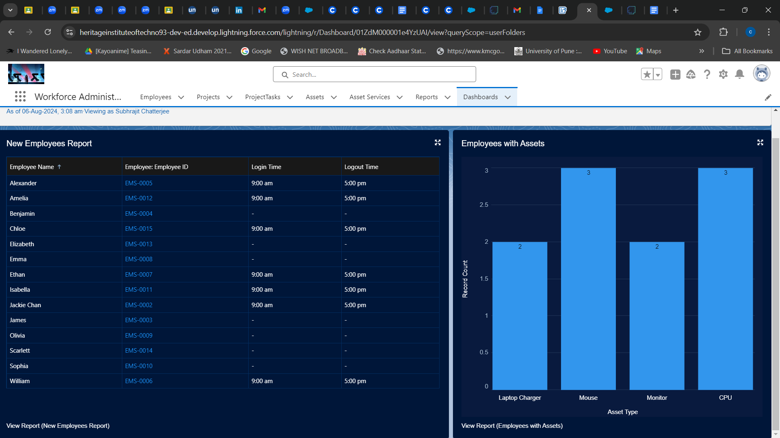

## TASK 41: **Create Another Dashboard**

1. Go to the app --> click on the Dashboards tabs.

2. Give a Name and click on Create.

3. Select add component.

4. Select another Report and click on select.

5. Click Add then click on Save and then click on Done.

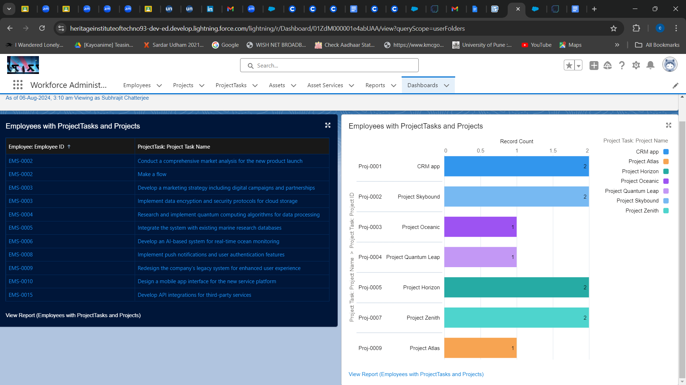

# **THANK YOU**